**Facts about Covid-19**

**Updated**: [June 2020](https://swprs.org/a-swiss-doctor-on-covid-19/#latest); **Share on**: [Twitter](https://twitter.com/intent/tweet?url=https://swprs.org/a-swiss-doctor-on-covid-19/) / [Facebook](https://www.facebook.com/share.php?u=https://swprs.org/a-swiss-doctor-on-covid-19/)  
**Languages**: [CZ](https://swprs.org/fakta-o-covid-19/), [DE](https://swprs.org/covid-19-hinweis-ii/), [EN](https://swprs.org/a-swiss-doctor-on-covid-19/), [EO](https://swprs.org/faktoj-pri-kovim-19/), [ES](https://swprs.org/hechos-sobre-covid-19/), [FI](https://swprs.org/faktoja-covid-19sta/), [FR](https://swprs.org/coronavirus-un-medecin-suisse-parle/), [GR](https://swprs.org/facts-about-covid19-greek/), [HBS](https://swprs.org/covid-19-cinjenice/), [HE](https://yanivhamo.com/facts-about-covid-19-hebrew/), [HU](https://swprs.org/egy-svajci-orvos-a-covid-19-rol/), [IT](https://swprs.org/un-medico-svizzero-su-covid-19/), [JP](https://swprs.org/covid19-facts-japanese/), [KO](https://swprs.org/covid19-korean/), [NO](https://midtifleisen.wordpress.com/2020/04/15/fakta-om-covid-19/), [PL](https://swprs.org/szwajcarski-lekarz-o-covid-19/), [PT](https://swprs.org/fatos-sobre-covid-19/), [RO](https://swprs.org/informatii-despre-covid-19/), [RU](https://swprs.org/%d0%bd%d0%b0-%d0%ba%d0%be%d0%b2%d0%b8%d0%b4-19/), [SE](https://swprs.org/fakta-om-covid-19/), [SI](http://www.ninamvseeno.org/pregled-clanka.aspx?naslov=pomembne-informacije-o-novem-koronavirusu-covid-19&id=148), [SK](https://alatyr.sk/covid-19_swiss_propaganda_research.htm), [TR](https://swprs.org/isvicreli-bir-doktordan-kovid-19-uezerine/)

Fully referenced facts about Covid-19, provided by experts in the field, to help our readers make a realistic risk assessment. (Regular updates below)

**“The only means to fight the plague is honesty.” (Albert Camus, 1947)**

**Overview**

1. According to the latest immunological and serological studies, the overall lethality of Covid-19 (IFR) is [about 0.1%](https://swprs.org/studies-on-covid-19-lethality/) and thus in the range of a strong seasonal [influenza](https://www.ebm-netzwerk.de/en/publications/covid-19) (flu).
2. In countries like the US, the UK, and also Sweden (without a lockdown), overall mortality since the beginning of the year [is in the range of](https://swprs.org/studies-on-covid-19-lethality/#overall-mortality) a strong influenza season; in countries like Germany, Austria and Switzerland, overall mortality is in the range of a mild influenza season.
3. Even in global “hotspots”, the risk of death for the general population of school and working age is typically in the range of [a daily car ride to work](https://www.medrxiv.org/content/10.1101/2020.04.05.20054361v1). The risk was initially overestimated because many people with only mild or no symptoms were not taken into account.
4. Up to 80% of all test-positive persons [remain symptom-free](https://www.bmj.com/content/369/bmj.m1375). Even among 70-79 year olds, [about 60%](https://www.niid.go.jp/niid/en/2019-ncov-e/9407-covid-dp-fe-01.html) remain symptom-free. Over 95% of all persons develop at most [moderate symptoms](https://swprs.org/studies-on-covid-19-lethality/#hospitalizations).
5. Up to 60% of all persons may already have a certain cellular [background immunity](https://www.cell.com/cell/fulltext/S0092-8674(20)30610-3) to Covid19 due to contact with previous coronaviruses (i.e. common cold viruses).
6. The median or average [age of the deceased](https://swprs.org/studies-on-covid-19-lethality/#age) in most countries (including Italy) is over 80 years and [only about 4%](https://www.bloomberg.com/news/articles/2020-05-26/italy-says-96-of-virus-fatalities-suffered-from-other-illnesses) of the deceased had no serious preconditions. The age and risk profile of deaths thus essentially corresponds to [normal mortality](https://www.vienna.at/analyse-zeigt-covid-19-opferkurve-entspricht-normaler-mortalitaet/6581246).
7. In many countries, up to two thirds of all extra deaths occurred [in nursing homes](https://swprs.org/studies-on-covid-19-lethality/#care-homes), which do not benefit from a general lockdown. Moreover, in many cases it is [not clear](https://www.hsj.co.uk/commissioning/thousands-of-extra-deaths-outside-hospital-not-attributed-to-covid-19/7027459.article) whether these people really died from Covid19 or from weeks of [extreme stress and isolation](https://www.theguardian.com/world/2020/jun/05/covid-19-causing-10000-dementia-deaths-beyond-infections-research-says).
8. Up to 30% of all additional deaths may have been caused [not by Covid19](https://www.ons.gov.uk/peoplepopulationandcommunity/birthsdeathsandmarriages/deaths/articles/analysisofdeathregistrationsnotinvolvingcoronaviruscovid19englandandwales28december2019to1may2020/technicalannex), but by the effects of the [lockdown, panic and fear](https://www.telegraph.co.uk/global-health/science-and-disease/two-new-waves-deaths-break-nhs-new-analysis-warns/). For example, the treatment of heart attacks and strokes [decreased](https://www.nytimes.com/2020/04/06/well/live/coronavirus-doctors-hospitals-emergency-care-heart-attack-stroke.html) by up to 60% because many patients no longer dared to go to hospital.
9. Even in so-called “Covid19 deaths” it is often [not clear](https://spectator.us/understand-report-figures-covid-deaths/) whether they died *from* or *with* coronavirus (i.e. from underlying diseases) or if they were counted as [“presumed cases”](https://www.youtube.com/watch?v=V0lIWZpiRU0) and not tested at all. However, official figures usually [do not reflect](https://www.hsj.co.uk/coronavirus/systematic-reviews-to-discover-true-cause-of-outbreak-deaths/7027491.article) this distinction.
10. Many media reports of young and healthy people dying from Covid19 turned out to be false: many of these young people either [did not die](https://www.dailymail.co.uk/news/article-8193487/Coroner-refuses-rule-COVID-19-cause-death-six-week-old-Connecticut-baby.html) from Covid19, they had already been [seriously ill](https://sports.yahoo.com/spanish-football-coach-francisco-garcia-163153573.html) (e.g. from undiagnosed leukaemia), or they were in fact [109 instead of 9](https://www.n-tv.de/panorama/Neunjaehrige-Corona-Tote-war-109-Jahre-alt-article21753784.html) years old. The claimed increase in Kawasaki disease in children also turned out [to be false](https://www.societi.org.uk/kawasaki-disease-covid-19/responding-to-press-coverage-28-april-2020/).
11. Strong increases in regional mortality can occur if there is a [collapse in the care of the elderly and sick](https://swprs.org/covid-19-a-report-from-italy/) as a result of infection or panic, or if there are additional risk factors such as [severe air pollution](https://www.theguardian.com/environment/2020/apr/20/air-pollution-may-be-key-contributor-to-covid-19-deaths-study). Questionable [regulations](https://www.ecdc.europa.eu/sites/default/files/documents/COVID-19-safe-handling-of-bodies-or-persons-dying-from-COVID19.pdf) for dealing with the deceased sometimes led to [additional bottlenecks](https://www.globalresearch.ca/truth-behind-refrigerated-morgue-truck-stories/5711475) in funeral or cremation services.
12. In countries such as Italy and Spain, and to some extent the UK and the US, hospital overloads due to strong flu waves [are not unusual](https://off-guardian.org/2020/04/02/coronavirus-fact-check-1-flu-doesnt-overwhelm-our-hospitals/). Moreover, this year up to 15% of health care workers were [put into quarantine](https://www.nytimes.com/2020/03/24/world/europe/coronavirus-europe-covid-19.html), even if they developed no symptoms.
13. The often shown exponential curves of “corona cases” are [misleading](https://fivethirtyeight.com/features/coronavirus-case-counts-are-meaningless/), as the number of tests also increased exponentially. In most countries, the ratio of positive tests to tests overall (i.e. the positive rate) remained [constant at 5% to 25%](https://swprs.org/rate-of-positive-covid19-tests/) or increased only slightly. In many countries, the peak of the spread was already reached well [before the lockdown](https://www.dailymail.co.uk/news/article-8391141/Did-UKs-coronavirus-crisis-peak-lockdown.html).
14. Countries *without* curfews and contact bans, such as [Japan](https://www.bloomberg.com/news/articles/2020-05-22/did-japan-just-beat-the-virus-without-lockdowns-or-mass-testing), [South Korea](https://www.businessinsider.com/south-korea-coronavirus-testing-death-rate-2020-3?op=1), [Belarus](https://www.forbes.com/sites/jamesrodgerseurope/2020/04/04/in-belarus-lukashenko-has-his--own-ways-for-the-country-to-face-coronavirus/) or [Sweden](https://www.youtube.com/watch?v=bfN2JWifLCY), have [not experienced](https://www.washingtontimes.com/news/2020/apr/15/sweden-coronavirus-rates-easing-despite-loose-rule/) a more negative course of events than other countries. Sweden was even [praised](https://nypost.com/2020/04/29/who-lauds-sweden-as-model-for-resisting-coronavirus-lockdown/) by the WHO and now benefits from higher immunity compared to lockdown countries.
15. The fear of a shortage of ventilators was [unjustified](https://off-guardian.org/2020/05/06/covid19-are-ventilators-killing-people/). According to lung specialists, the invasive ventilation (intubation) of Covid19 patients, which is partly done [out of fear](https://nypost.com/2020/05/29/northwell-health-probing-use-of-ventilators-for-covid-patients/) of spreading the virus, is in fact often [counterproductive](https://off-guardian.org/2020/05/06/covid19-are-ventilators-killing-people/) and damaging to the lungs.
16. Contrary to original assumptions, various studies [have shown](https://www.telegraph.co.uk/news/2020/04/02/no-proof-coronavirus-can-spread-shopping-says-leading-german/) that there is [no evidence](https://www.who.int/news-room/commentaries/detail/modes-of-transmission-of-virus-causing-covid-19-implications-for-ipc-precaution-recommendations) of the virus spreading through aerosols (i.e. tiny particles *floating* in the air) or through smear [infections](https://www.yahoo.com/lifestyle/cdc-coronavirus-mainly-spreads-through-persontoperson-contact-and-does-not-spread-easily-on-contaminated-surfaces-153317029.html) (e.g. on door handles or smartphones). The main modes of transmission are *direct* contact and *droplets* produced when coughing or sneezing.
17. There is also [no scientific evidence](https://www.cidrap.umn.edu/news-perspective/2020/04/commentary-masks-all-covid-19-not-based-sound-data) for the effectiveness of face masks in *healthy* or *asymptomatic* individuals. On the contrary, experts warn that such masks interfere with normal breathing and may become [“germ carriers”](https://www.independent.co.uk/news/health/coronavirus-news-face-masks-increase-risk-infection-doctor-jenny-harries-a9396811.html). Leading doctors called them a “media hype” and [“ridiculous”](https://www.aerztezeitung.de/Politik/Montgomery-haelt-Maskenpflicht-fuer-falsch-408844.html).
18. Many clinics in Europe and the US remained [strongly underutilized](https://www.hsj.co.uk/acute-care/nhs-hospitals-have-four-times-more-empty-beds-than-normal/7027392.article) or [almost empty](https://www.sfchronicle.com/bayarea/article/Stanford-hospital-system-to-cut-pay-20-furlough-15227591.php) during the Covid19 peak and in some cases had to [send staff home](https://www.usatoday.com/story/news/health/2020/04/02/coronavirus-pandemic-jobs-us-health-care-workers-furloughed-laid-off/5102320002/). Millions of surgeries and therapies were [cancelled](https://www.birmingham.ac.uk/news/latest/2020/05/covid-disruption-28-million-surgeries-cancelled.aspx), including many cancer screenings and organ transplants.
19. Several media were caught [trying to dramatize](https://nypost.com/2020/04/01/cbs-admits-to-using-footage-from-italy-in-report-about-nyc/) the situation in hospitals, sometimes even with [manipulative](https://www.wsj.com/articles/cbs-says-fake-news-wasnt-theirs-11588789238) images and videos. In general, the [unprofessional reporting](https://onlinelibrary.wiley.com/doi/full/10.1111/eci.13222) of many media maximized fear and panic in the population.
20. The virus test kits used internationally are [prone to errors](https://www.ncbi.nlm.nih.gov/pubmed/32219885) and can produce false positive and false negative results. Moreover, the official virus test was [not clinically validated](https://www.youtube.com/watch?v=p_AyuhbnPOI) due to time pressure and may sometimes react positive to other coronaviruses.
21. Numerous [internationally renowned experts](https://off-guardian.org/2020/03/24/12-experts-questioning-the-coronavirus-panic/) in the fields of virology, immunology and epidemiology consider the measures taken to be [counterproductive](https://off-guardian.org/2020/03/28/10-more-experts-criticising-the-coronavirus-panic/) and recommend rapid [natural immunisation](https://off-guardian.org/2020/04/17/8-more-experts-questioning-the-coronavirus-panic/) of the general population and protection of risk groups.
22. At no time was there [a medical reason](https://www.thelancet.com/journals/lanchi/article/PIIS2352-4642(20)30095-X/fulltext) for the closure of schools, as the risk of disease and transmission in children is [extremely low](https://thehill.com/opinion/education/500349-science-says-open-the-schools). There is also [no medical reason](https://www.welt.de/politik/deutschland/article208075525/Corona-Kitas-und-Grundschulen-vollstaendig-oeffnen-uneingeschraenkt.html) for small classes, masks or ‘social distancing’ rules in schools.
23. The claim that only (severe) Covid-19 but not influenza may cause venous thrombosis and pulmonary (lung) embolism is not true, as it has been known [for 50 years](https://www.thieme-connect.com/products/ejournals/abstract/10.1055/s-0028-1108874) that severe influenza [greatly increases the risk](https://www.sciencedaily.com/releases/2009/10/091014111549.htm) of thrombosis and embolism, too.
24. Several medical experts [described](https://www.news.com.au/lifestyle/health/health-problems/no-vaccine-for-coronavirus-a-possibility/news-story/34e678ae205b50ea983cc64ab2943608) express coronavirus vaccines as [unnecessary](https://www.youtube.com/watch?v=vrL9QKGQrWk) or even [dangerous](https://www.nature.com/articles/d41586-020-00751-9). Indeed, the vaccine against the [so-called swine flu](https://www.forbes.com/2010/02/05/world-health-organization-swine-flu-pandemic-opinions-contributors-michael-fumento.html#658c006c48e8) of 2009, for example, led to sometimes [severe neurological damage](https://www.ibtimes.co.uk/brain-damaged-uk-victims-swine-flu-vaccine-get-60-million-compensation-1438572) and lawsuits in the millions. In the testing of new coronavirus vaccines, too, serious [complications](https://childrenshealthdefense.org/news/vaccine-trial-catastrophe-moderna-vaccine-has-20-serious-injury-rate-in-high-dose-group/) and [failures](https://www.forbes.com/sites/williamhaseltine/2020/05/16/did-the-oxford-covid-vaccine-work-in-monkeys-not-really/) have already occurred.
25. A global influenza or corona pandemic can indeed extend over [several seasons](https://www.britannica.com/event/1968-flu-pandemic), but many studies of a “second wave” are based on [very unrealistic assumptions](https://www.heise.de/tp/features/Fellay-Studie-Zweite-Corona-Welle-4726303.html), such as a constant risk of illness and death across all age groups.
26. Several nurses, e.g. in New York City, described an oftentimes [fatal medical mis­manage­ment](https://www.youtube.com/watch?v=UIDsKdeFOmQ) of Covid patients due to questionable [financial incentives](https://eu.usatoday.com/story/news/factcheck/2020/04/24/fact-check-medicare-hospitals-paid-more-covid-19-patients-coronavirus/3000638001/) or inappropriate medical protocols.
27. The number of people suffering from unemployment, [depressions](https://www.indystar.com/story/news/health/2020/04/03/coronavirus-indiana-how-get-help-mental-health-addiction/5104357002/) and domestic violence as a result of the measures has reached [historic record values](https://www.businessinsider.com/us-weekly-jobless-claims-unemployment-filings-coronavirus-labor-market-layoffs-2020-5). Several experts predict that the measures will claim [far more lives](https://www.nytimes.com/2020/03/20/opinion/coronavirus-pandemic-social-distancing.html) than the virus itself. According to the UN [1.6 billion people](https://www.theguardian.com/world/2020/apr/29/half-of-worlds-workers-at-immediate-risk-of-losing-livelihood-due-to-coronavirus) around the world are at immediate risk of losing their livelihood.
28. NSA whistleblower Edward Snowden warned that the “corona crisis” will be used for the [permanent expansion](https://www.youtube.com/watch?v=-pcQFTzck_c) of global surveillance. Renowned virologist Pablo Goldschmidt [spoke of](https://www.rubikon.news/artikel/der-corona-totalitarismus) a “global media terror” and “totalitarian measures”. Leading British virologist Professor John Oxford [spoke of](https://novuscomms.com/2020/03/31/a-view-from-the-hvivo-open-orphan-orph-laboratory-professor-john-oxford/) a “media epidemic”.
29. More than 600 scientists [have warned of](https://www.esat.kuleuven.be/cosic/sites/contact-tracing-joint-statement/) an “unprecedented surveillance of society” through problematic apps for “contact tracing”. In some countries, such “contact tracing” is already carried out directly [by the secret service](https://www.jewishpress.com/news/the-courts/state-to-high-court-even-more-shin-bet-involvement-in-fighting-the-coronavirus/2020/04/14/). In several parts of the world, the population is already being [monitored by drones](https://off-guardian.org/2020/04/25/50-headlines-darker-more-of-the-new-normal/) and facing serious police overreach.
30. A 2019 WHO study on public health measures against pandemic influenza found that from a medical perspective, “contact tracing” is [“not recommended in any circumstances”](https://apps.who.int/iris/bitstream/handle/10665/329438/9789241516839-eng.pdf#page=9). Nevertheless, contact tracing apps have already [become](https://www.heise.de/tp/features/CuidAR-Argentinien-ueberwacht-mit-einer-App-4720143.html) partially mandatory in [several countries](https://www.technologyreview.com/2020/05/07/1001360/india-aarogya-setu-covid-app-mandatory/).

**See also**:

* [Studies on Covid-19 lethality (overview)](https://swprs.org/studies-on-covid-19-lethality/)
* [Open Letter by Professor Sucharit Bhakdi](https://swprs.org/open-letter-from-professor-sucharit-bhakdi-to-german-chancellor-dr-angela-merkel/)
* [European Mortality Monitoring (EuroMomo)](https://www.euromomo.eu/)

**June 2020**

**A. General part**

**Studies of Covid-19 lethality**

Stanford professor John Ioannidis published an [overview of Covid-19 antibody studies](https://swprs.org/studies-on-covid-19-lethality/). According to his analysis, the lethality of Covid19 (IFR) is below 0.16% in most countries and regions. Ioannidis found an upper limit of 0.40% for three hotspots.

In its [latest report,](https://reason.com/2020/05/24/the-cdcs-new-best-estimate-implies-a-covid-19-infection-fatality-rate-below-0-3/) the US health authority CDC reduced the Covid19 lethality (IFR) to 0.26% (best estimate). Even this value may still be seen as an upper limit, since the CDC conservatively assumes 35% asymptomatic cases, while most studies indicate [50 to 80%](https://www.bmj.com/content/369/bmj.m1375) asymptomatic cases.

At the end of May, however, Swiss immunologists led by Professor Onur Boyman published what is probably the [most important study](https://swprs.org/coronavirus-antibody-tests-show-only-one-fifth-of-infections/) on Covid19 lethality to date. This preprint study comes to the conclusion that the usual antibody tests that measure antibodies in the blood (IgG and IgM) can recognize **at most one fifth** of all Covid19 infections.

The reason for this discrepancy is that in most people the new coronavirus is already neutralized by antibodies on the mucous membrane (IgA) or by cellular immunity (T-cells). In most of these cases, no symptoms or only mild symptoms develop.

This means that the new coronavirus is probably much more common than previously thought and the lethality per infection is up to five times lower than previously assumed. The real lethality could thus be **well below 0.1%** and hence in the range of strong seasonal influenza.

In fact, several studies have now shown that up to 60% of all people already have a certain [cellular immunity](https://www.cell.com/cell/fulltext/S0092-8674(20)30610-3) to Covid-19, which was acquired through contact with previous coronaviruses (common cold viruses). Children in particular often come into contact with such coronaviruses, which could help explain their insensitivity to Covid19.

The new Swiss study may also explain why antibody studies even in **hotspots** like New York or Madrid found infection rates of [at most about 20%](https://www.governor.ny.gov/news/amid-ongoing-covid-19-pandemic-governor-cuomo-announces-results-completed-antibody-testing), as this would correspond to an actual rate of nearly 100%. In many regions, the actual prevalence might already be well [over 50%](https://swprs.org/studies-on-covid-19-lethality/) and thus in the range of ​​herd immunity.

Should the Swiss study be confirmed, the assessment of Oxford epidemiologist Prof. **Sunetra Gupta** would apply**,** who predicted early on that Covid-19 is very widespread and its lethality [below 0.1%](https://unherd.com/2020/05/oxford-doubles-down-sunetra-gupta-interview/).

Despite the comparatively low **lethality** of Covid-19 (deaths per infection), the **mortality** (deaths per population) can still be increased regionally and in the short term if the virus spreads rapidly and reaches high risk groups, especially patients in nursing homes, as indeed happened in several hotspots (see below).

Due to its rather low lethality, Covid-19 falls at most into level 2 of the five-level [pandemic plan](https://www.cidrap.umn.edu/news-perspective/2007/02/hhs-ties-pandemic-mitigation-advice-severity) developed by US health authorities. For this level, only the **“voluntary isolation of sick people”** is to be applied, while further measures such as face masks, school closings, distance rules, contact tracing, vaccinations and lockdowns of entire societies are not recommended.

Regarding **contact tracing**, a WHO study on influenza pandemics from 2019 also came to the conclusion that from a medical point of view this is [“under no circumstances recommended”](https://apps.who.int/iris/bitstream/handle/10665/329438/9789241516839-eng.pdf), since it is not expedient for easily communicable and generally mild respiratory diseases.

It is sometimes argued that the rather low lethality was not known at the beginning of the pandemic. This is not entirely true, as data from South Korea, the cruise ships and even from Italy already [showed in March](https://www.statnews.com/2020/03/17/a-fiasco-in-the-making-as-the-coronavirus-pandemic-takes-hold-we-are-making-decisions-without-reliable-data/) that the risk to the general population is rather low.

Many health authorities also knew this, as [leaked emails from Denmark](https://www.thelocal.dk/20200529/leaked-emails-show-how-denmarks-pm-steam-rollered-her-own-health-agency) in mid-March show: “The Danish Health Authority continues to consider that Covid-19 cannot be described as a generally dangerous disease, as it does not have either a usually serious course or a high mortality rate.”

Some media nevertheless continue to calculate an allegedly much higher Covid19 lethality rate of sometimes over 1% by simply [dividing](https://english.elpais.com/society/2020-05-14/antibody-study-shows-just-5-of-spaniards-have-contracted-the-coronavirus.html) deaths by “infections”, without taking into account the age and risk distribution, which is absolutely crucial especially for Covid19.

The latest data from the European mortality monitoring [Euromomo](https://www.euromomo.eu/graphs-and-maps/) shows that several countries such as France, Italy and Spain are already entering a **below-average mortality**. The reason for this is that the average age of Covid19 deaths was very high and fewer people than usual are now dying in this age group.

**See also**: [Studies on Covid-19 lethality](https://swprs.org/studies-on-covid-19-lethality/)

[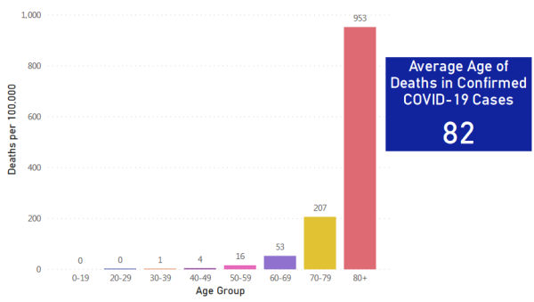](https://swprs.files.wordpress.com/2020/05/death-rate-age-groups-ma.png)Example: Death rate per age group in Massachusetts, USA ( [source](https://www.mass.gov/doc/covid-19-dashboard-may-6-2020/download) )

**The role of nursing homes**

Nursing homes played an [absolute key role](https://ltccovid.org/2020/04/12/mortality-associated-with-covid-19-outbreaks-in-care-homes-early-international-evidence/) in the Covid 19 pandemic. In most countries, one to two thirds of all Covid19 deaths occurred in nursing homes, and [up to 80%](https://freopp.org/the-covid-19-nursing-home-crisis-by-the-numbers-3a47433c3f70) in Canada and some US states. Even in Sweden, which did not impose a lockdown, [75% of deaths](https://www.thelocal.se/20200525/swedish-death-toll-passes-4000-as-coronavirus-cases-in-care-homes-start-to-fall) occurred in nursing facilities.

It is all the more worrying that some authorities have *obliged* their nursing homes to admit Covid patients from the clinics, which has almost always resulted in numerous new infections and deaths. This happened in [northern Italy](https://www.trtworld.com/magazine/the-massacre-of-italy-s-elderly-nursing-home-residents-35575), England and the heavily affected US states of [New York](https://nypost.com/2020/05/12/calls-for-independent-probe-of-gov-cuomos-nursing-home-policies/), New Jersey and [Pennsylvania](https://nypost.com/2020/05/13/pennsylvania-health-official-moved-mother-from-nursing-home/).

It is also known from northern Italy that the widespread fear of the virus and the announced lockdown of the country led to the flight of the predominantly Eastern European nurses, which [further accelerated](https://swprs.org/covid-19-a-report-from-italy/) the breakdown of elderly care.

In the United States, [at least 42% of](https://www.forbes.com/sites/theapothecary/2020/05/26/nursing-homes-assisted-living-facilities-0-6-of-the-u-s-population-43-of-u-s-covid-19-deaths/) all Covid19 deaths are accounted for by 0.6% of the population living in nursing homes. Nursing homes require targeted protection and do not benefit from a general lockdown of society as a whole.

It is well known that even common corona viruses (cold viruses) can be very dangerous for people in nursing homes. Stanford professor John Ioannidis pointed out already in mid-March that coronaviruses may have a case [mortality rate of up to 8%](https://www.statnews.com/2020/03/17/a-fiasco-in-the-making-as-the-coronavirus-pandemic-takes-hold-we-are-making-decisions-without-reliable-data/) in nursing homes.

In addition, it is often not clear whether these people really died from Covid-19 or from weeks of stress and total isolation. For example, there were approximately 30,000 additional deaths in English nursing homes, but in only 10,000 cases, Covid19 is noted [on the death certificate](https://www.bmj.com/content/369/bmj.m1931).

In April alone, around [10,000 additional dementia patients](https://www.theguardian.com/world/2020/jun/05/covid-19-causing-10000-dementia-deaths-beyond-infections-research-says) *without* corona infection died in England and Wales due to weeks of isolation. Investigations into the situation in nursing homes have been [initiated](https://www.theguardian.com/world/2020/apr/16/italian-police-broaden-care-home-coronavirus-milan) or [requested](https://nypost.com/2020/05/12/calls-for-independent-probe-of-gov-cuomos-nursing-home-policies/) in several countries.

[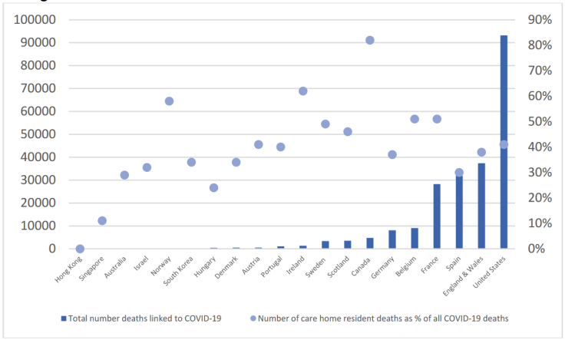](https://swprs.files.wordpress.com/2020/05/care-home-deaths-may-21.png)Nursing home deaths, absolute and percentage ( [LTCCovid](https://ltccovid.org/2020/04/12/mortality-associated-with-covid-19-outbreaks-in-care-homes-early-international-evidence/) )

**The role of hospitals**

The second central factor regarding infections and deaths, in addition to the nursing homes, are the hospitals themselves. A [case study in Wuhan](https://jamanetwork.com/journals/jama/fullarticle/2761044) already showed that around 41% of hospitalized Covid patients had in fact contracted Covid in the hospital itself.

Contagion in hospitals also played a [decisive role](https://medium.com/%40tepper_jonathan/ground-zero-when-the-cure-is-worse-than-the-disease-3c513d91393d) in northern Italy, Spain, England and other regions that were severely affected, meaning that the clinics themselves became the main place of transmission of Covid19 to already weakened people (so-called nosocomial infection) – an issue that had already been [observed](https://onlinelibrary.wiley.com/doi/10.1046/j.1440-1843.2003.00523.x) during the SARS outbreak from 2003.

Based on current knowledge, those countries that managed to avoid outbreaks of infection in nursing homes and hospitals had comparatively few deaths. The general lockdown of society, however, played no role or even a counterproductive role (see below).

An additional factor is the sometimes fatal medical mistreatment of Covid patients with aggressive drugs or invasive ventilation, the risks of which experts [have been warning about](https://off-guardian.org/2020/05/06/covid19-are-ventilators-killing-people/) for months. In the US, for example, there have been questionable [financial incentives](https://eu.usatoday.com/story/news/factcheck/2020/04/24/fact-check-medicare-hospitals-paid-more-covid-19-patients-coronavirus/3000638001/) to connect Covid patients to ventilators, a practice that is now [being investigated](https://nypost.com/2020/05/29/northwell-health-probing-use-of-ventilators-for-covid-patients/) in several states.

**See also**: [An undercover nurse reporting from the ‘epicenter’ in New York City](https://www.youtube.com/watch?v=UIDsKdeFOmQ) (Video)

**The clinical picture of Covid-19**

The well-known Hamburg medical examiner Professor Klaus Püschel presented his [study](https://www.acpjournals.org/doi/10.7326/M20-2003) (English) on the first 12 of 190 detailed corona autopsies at a [press conference](https://www.youtube.com/watch?v=GXhxorBBPYI) (German).

Professor Püschel again emphasized that Covid-19 “is not nearly as threatening as was initially suspected”. The danger was “too much influenced by media images”. The media had focused on severe individual cases and fueled panic with “completely wrong messages”. Covid-19 is not a “killer virus” and the call for new medicine or vaccines is “driven by fear, not facts.”

The specific cause of death of the examined cases was pneumonia, but in about 50% of the cases there were venous thrombosis in the legs, which can lead to fatal pulmonary embolism. The kidneys and heart muscle were also partially affected. Professor Püschel therefore recommends the preventive administration of blood-thinning medication for serious Covid cases.

With regard to thrombosis and pulmonary embolism, Professor Püschel – like other experts before – emphasized that a “lockdown” with quarantine at home was “exactly the wrong measure”, since the lack of exercise itself promotes thrombosis. Indeed, US specialists have already been [warning](https://twitter.com/AlexBerenson/status/1258625618431954945) of this risk after even *Covid-negative* [people](https://twitter.com/AlexBerenson/status/1259548620724080640) developed [unexpected](https://twitter.com/AlexBerenson/status/1259634922161147910) thrombosis.

Many media again misinterpreted the autopsy findings and spoke of Covid-19 as a particularly dangerous disease which, unlike influenza, is said to lead to thrombosis and pulmonary embolism. This is not true, however: it has been [known](https://www.thieme-connect.com/products/ejournals/abstract/10.1055/s-0028-1108874) for 50 years that even severe influenza can [greatly increase](https://www.ejinme.com/article/S0953-6205(15)00284-8/pdf) [the risk](https://www.sciencedaily.com/releases/2009/10/091014111549.htm) of thrombosis and embolism and can affect the [heart muscle](https://academic.oup.com/ije/article-abstract/7/3/231/755276) and other organs. Even the recommendation regarding preventive blood thinner for severe influenza has been around [for 50 years](https://www.thieme-connect.com/products/ejournals/abstract/10.1055/s-0028-1108874) already.

**Children and schools**

Numerous studies [have now shown](https://thehill.com/opinion/education/500349-science-says-open-the-schools) that children hardly get Covid19 and do not or hardly transmit the virus, which was [already known](https://www.thelancet.com/journals/lanchi/article/PIIS2352-4642(20)30095-X/fulltext) from the 2003 SARS outbreak. There was therefore [no medical reason](https://infekt.ch/2020/04/schulen-schliessen-hilfreich-oder-nicht/) for the closure of schools at any time.

Accordingly, all those [countries](https://www.reuters.com/article/us-health-coronavirus-denmark-reopening/opening-schools-in-denmark-did-not-worsen-outbreak-data-shows-idUSKBN2341N7) that reopened their schools in May saw [no increase](https://www.cgdev.org/blog/back-school-tracking-covid-cases-schools-reopen) in cases of infection. Countries like Sweden, which never closed their primary schools anyway, had no problems with this either.

A preprint study by the German virologist Christian Drosten argued that the risk of infection from children is comparable to adults and schools should therefore remain closed. However, several researchers demonstrated [methodological errors](https://www.nau.ch/news/europa/coronavirus-forscher-drangen-drosten-zum-ruckzug-der-kinder-studie-65714012) in the study. Drosten subsequently withdrew the recommendation regarding school closures.

In some schools, for example in France and Israel, alleged [“corona outbreaks” are](https://www.npr.org/sections/coronavirus-live-updates/2020/06/03/868507524/israel-orders-schools-to-close-when-covid-19-cases-are-discovered) said to have occurred. However, it is likely that these are transmissions from teachers to schoolchildren that, to their dismay, are regularly tested, although they hardly show any symptoms and are themselves hardly or not at all contagious.

The British *Kawasaki Disease Foundation* again criticized the [dubious and lurid media coverage of](https://www.societi.org.uk/kawasaki-disease-and-covid-19/) *Kawasaki disease*. In fact, there has been no significant increase in Kawasaki cases and no proven association with Covid-19. General inflammatory reactions in individual children are also known from other viral infections, but the number of cases reported so far is extremely low.

German medical associations [have also given the all-clear](https://www.welt.de/politik/deutschland/article208075525/Corona-Kitas-und-Grundschulen-vollstaendig-oeffnen-uneingeschraenkt.html): Covid-19 is imperceptible or very mild in almost all children. Schools and daycare centers should therefore be opened immediately and without restrictions, ie there is no need for small groups, distance rules or masks.

[](https://swprs.files.wordpress.com/2020/06/school-kids-france.jpg)Schoolchildren in France who have to play in boxes (May 15, 2020, [DailyMail](https://www.dailymail.co.uk/news/article-8314697/Heart-breaking-photo-children-forced-play-isolation-zones-sparks-outcry-France.html) )

**On the effectiveness of masks**

Regardless of the comparatively low lethality of Covid19 in the general population (see above), there is still [no scientific evidence](https://off-guardian.org/2020/06/06/coronavirus-fact-check-6-does-wearing-a-mask-do-anything/) for the effectiveness of masks in healthy and asymptomatic people in everyday life.

A cross-country study by the University of East Anglia came to the conclusion that a mask requirement was of [no benefit](https://www.uea.ac.uk/about/-/new-study-reveals-blueprint-for-getting-out-of-covid-19-lockdown) and could even increase the risk of infection.

Two US professors and experts in respiratory and infection protection from the University of Illinois explain [in an essay](https://www.cidrap.umn.edu/news-perspective/2020/04/commentary-masks-all-covid-19-not-based-sound-data) that respiratory masks have no effect in everyday life, neither as self-protection *nor to protect third parties* (so-called source control). The widespread use of masks didn’t prevent the outbreak in the Chinese city of Wuhan, either.

A study from April 2020 in the journal *Annals of Internal Medicine* [came to the conclusion](https://www.acpjournals.org/doi/10.7326/M20-1342) that neither fabric masks nor surgical masks can prevent the spread of the Covid19 virus by coughing.

An article in the *New England Journal of Medicine* from May 2020 also comes to the conclusion that respiratory masks offer [little or no protection](https://www.nejm.org/doi/full/10.1056/NEJMp2006372) in everyday life. The call for a mask requirement is described as an “irrational fear reflex”.

A May 2020 meta-study on pandemic influenza published by the U.S. CDC [also found](https://wwwnc.cdc.gov/eid/article/26/5/19-0994_article) that respirators had no effect.

The WHO moreover declared in June that truly “asymptomatic transmission” is in fact [“very rare”](https://www.nationalreview.com/news/who-says-transmission-by-asymptomatic-covid-patients-very-rare/), as data from numerous countries showed. Some of the few confirmed cases were due to [direct body contact](https://wwwnc.cdc.gov/eid/article/26/8/20-1235_article), i.e. shaking hands or kissing.

In Austria, the mask requirement in retail and catering will [be lifted again](https://www.derstandard.at/story/2000117792769/die-maske-wird-wieder-zurueckgedraengt) from mid-June. A mask requirement was [never introduced](https://www.thelocal.se/20200514/explained-why-is-sweden-not-recommending-face-masks-to-the-public) in Sweden because it “does not offer additional protection for the population”, as the health authority explained.

Numerous politicians, media people and police officers have already [been caught](https://www.youtube.com/watch?v=y2qAKS6Hl4I) putting on their respirators in a crowd especially for the [television cameras](https://twitter.com/DailyCaller/status/1265382872631980032) or taking them off immediately when they [believed that](https://twitter.com/realPowerTie/status/1261445611594723330) they were no longer being filmed.

In some cases there were [brutal police attacks](https://twitter.com/DrRJKavanagh/status/1260739779177656325) because a person allegedly “did not wear her mask properly”. In other cases, people with a disability who cannot and do not have to wear a mask, are [not allowed to enter](https://bnn.de/lokales/karlsruhe/maskenpflicht-behinderte-sind-befreit-und-werden-dafuer-teils-beschimpft) department stores .

Despite this evidence, a group called [“masks4all”](https://masks4all.co/about-us/), which was founded by a “young leader” of the World Economic Forum (WEF) Davos, is advocating worldwide mask requirements. Several governments [and the WHO](https://www.businessinsider.com/who-updates-face-masks-recommendations-amid-the-coronavirus-pandemic-2020-6) appear to be responding to this campaign.

Many critics suspect that the masks are more likely to have a psychological or [political function](https://multipolar-magazin.de/artikel/maskenpflicht-gesellschaftliches-klima) (“muzzle” or “visible sign of obedience”) and that wearing them frequently might even lead to additional health problems.

A study from Germany empirically showed that the introduction of face masks [had no effect](http://ftp.iza.org/dp13319.pdf#page=28) on infection rates (see graph). Only the city of Jena appeared to experience a strong decrease in infections, but Jena simultaneously introduced [very strict](https://www.mdr.de/thueringen/ost-thueringen/jena/corona-jena-seit-einer-woche-keine-neuinfektion-100.html) quarantine regulations.

[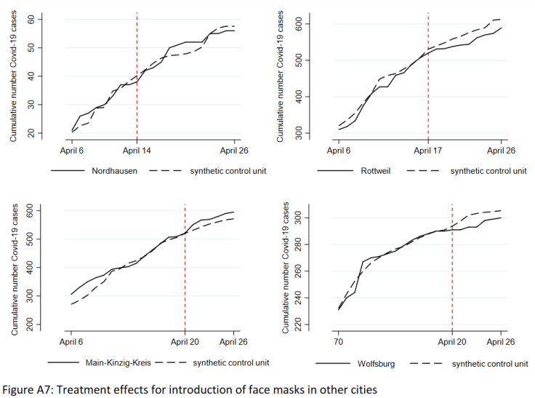](https://swprs.files.wordpress.com/2020/06/germany-face-masks-april-2020.png)Introduction of face masks in German cities had no impact on infections ([IZA](http://ftp.iza.org/dp13319.pdf#page=28))

**On the origin of the virus**

In mid-March, some researchers argued in a letter to the journal Nature Medicine that the Covid19 virus must be of [natural origin](https://www.nature.com/articles/s41591-020-0820-9) and not “from a laboratory”. They cited the structure of the virus and the fact that the binding to the human ACE2 cell receptor did not correspond to the theoretical maximum.

In the meantime, however, numerous [renowned virologists](https://www.independentsciencenews.org/health/the-case-is-building-that-covid-19-had-a-lab-origin/) have [contradicted](https://gmwatch.org/en/news/latest-news/19412-lab-escape-theory-of-sars-cov-2-origin-gaining-scientific-support) this argument. An artificial origin in the context of virological [functional research](https://medium.com/%40yurideigin/lab-made-cov2-genealogy-through-the-lens-of-gain-of-function-research-f96dd7413748) is “at least as plausible” as a natural origin. In fact, coronaviruses of this kind have been intensively [researched](https://gmwatch.org/en/news/latest-news/19410-chinese-and-us-scientists-genetically-engineered-bat-coronaviruses-in-dangerous-gain-of-function-research-stretching-back-years) in several laboratories for almost 20 years (i.e. since the SARS outbreak in 2003), they say.

Arguments *in favour* of an artificial origin include in particular that the binding to the human ACE2 cell receptor is [significantly stronger](https://arxiv.org/abs/2005.06199) than in all common source animals and that no direct source animal could be identified so far. In addition, the virus contains some striking functional [gene sequences](https://gmwatch.org/en/news/latest-news/19403-wuhan-and-us-scientists-used-undetectable-methods-of-genetic-engineering-on-bat-coronaviruses) that might have been inserted artificially (see graphic below).

The initial theory of the animal market in Wuhan has since been [rejected](https://thebulletin.org/2020/06/did-the-sars-cov-2-virus-arise-from-a-bat-coronavirus-research-program-in-a-chinese-laboratory-very-possibly) because none of the animals there tested positive and a third of the very first patients had no connection to the animal market. The animal market is now seen as a secondary place of transmission.

It is known that the virological laboratory in Wuhan, in collaboration with the United States and France, [researched](https://www.newsweek.com/dr-fauci-backed-controversial-wuhan-lab-millions-us-dollars-risky-coronavirus-research-1500741) coronaviruses and thereby also generated “potentially pandemic pathogens” (PPP) that are particularly easy to transmit and / or particularly dangerous. In addition, there have been several [laboratory accidents](https://www.independentsciencenews.org/health/the-long-history-of-accidental-laboratory-releases-of-potential-pandemic-pathogens/) with virus releases in China and the USA.

The unbiased observer must therefore continue to consider several realistic options: a natural origin of the virus (as assumed with SARS 2003), a [laboratory accident](https://project-evidence.github.io/) as part of functional research (probably in Wuhan), or even a targeted release by a geopolitically interested actor in the East or West.

Nevertheless, the Covid19 virus is not a “biological weapon” in the classic sense: the virus is [very easily transmissible](https://leelabvirus.host/covid19/origins-part2), but not particularly dangerous for the general population. Animal studies have shown that much more deadly corona viruses can be generated.

[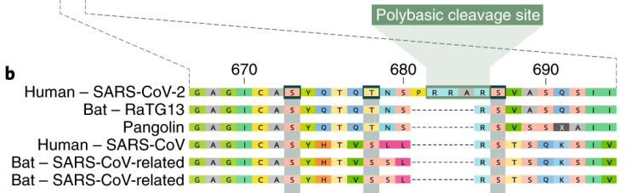](https://swprs.files.wordpress.com/2020/06/virus-sequence-comparison.png)Additional functional amino acids in the SARS-CoV-2 spike protein ([Andersen](https://www.nature.com/articles/s41591-020-0820-9), edited)

**Vaccines against Covid-19**

Various politicians in Europe and the US have declared that the “corona crisis” can only be ended by a vaccine that is currently being developed.

However, many experts have [pointed out](https://www.nature.com/articles/d41586-020-00751-9) that an express vaccine against the new coronavirus is [not necessary](https://www.youtube.com/watch?v=vrL9QKGQrWk) or useful due to the overall [low lethality](https://www.bitchute.com/video/DXxeej9CW1pz/) (see above) and the already [declining spread](https://www.news.com.au/lifestyle/health/health-problems/no-vaccine-for-coronavirus-a-possibility/news-story/34e678ae205b50ea983cc64ab2943608). The protection of risk groups, especially in nursing homes, could be much [more targeted](https://www.reuters.com/article/us-health-coronavirus-haseltine-newsmake-idUSKBN22W34T).

Some experts like the Swiss infectiologist Dr. Pietro Vernazza also pointed out that experience shows that the high-risk group in particular benefits [the least](https://infekt.ch/2020/05/corona-impfung-als-ultimative-rettung/) from vaccination, since their immune system no longer reacts adequately to the vaccine.

Various experts have also [pointed out](https://www.nature.com/articles/d41586-020-00751-9) the [significant health risks](https://www.reuters.com/article/us-health-coronavirus-vaccines-insight-idUSKBN20Y1GZ) of an express vaccine. In fact, vaccination against the so-called “swine flu” from 2009/2010, for example, led to sometimes [severe neurological damage,](https://www.ibtimes.co.uk/brain-damaged-uk-victims-swine-flu-vaccine-get-60-million-compensation-1438572) particularly in children, and to claims for damages in the millions.

Nevertheless, several billion dollars of private and public funds have already been [collected](https://www.nytimes.com/2020/05/04/world/europe/eu-coronavirus-vaccine.html) for the development of a vaccine. An “immunity certificate” for work and travel is [still being discussed](https://www.theguardian.com/politics/2020/may/03/coronavirus-health-passports-for-uk-possible-in-months). However, contrary to most media reports, the two leading [vaccine projects](https://www.thelancet.com/journals/lancet/article/PIIS0140-6736(20)31252-6/fulltext) had some serious complications.

In the case of the **Oxford University** vaccine, in animal experiments [all six rhesus monkeys](https://www.dailymail.co.uk/sciencetech/article-8331709/Oxford-coronavirus-vaccine-does-not-stop-infection-experts-warn.html) fell ill with Covid19 despite vaccination and were as infectious as the unvaccinated monkeys. Nevertheless, the vaccine was moved on to the human test phase. However, the project manager explained that the coronavirus had already *become so rare* in the population that the clinical trial may [deliver no result](https://www.telegraph.co.uk/news/2020/05/23/oxford-university-covid-19-vaccine-trial-has-50-per-cent-chance/).

In the case of the novel RNA vaccine from **Moderna**, which was unusually [tested](https://www.statnews.com/2020/03/11/researchers-rush-to-start-moderna-coronavirus-vaccine-trial-without-usual-animal-testing/) directly in human experiments, 20% of the participants in the high-dose group had a [“serious side effect”](https://childrenshealthdefense.org/news/vaccine-trial-catastrophe-moderna-vaccine-has-20-serious-injury-rate-in-high-dose-group/), although Moderna only allowed very healthy people to try it.

One of the Moderna participants was then presented and interviewed by CNN as a “hero”. However, it was agreed not to mention that the participant passed out after the vaccination and became [“as sick as never before in his life”](https://childrenshealthdefense.org/news/modernas-guinea-pig-sickest-in-his-life-after-being-injected-with-experimental-vaccine/). Several experts also criticized Moderna for [not disclosing](https://www.statnews.com/2020/05/19/vaccine-experts-say-moderna-didnt-produce-data-critical-to-assessing-covid-19-vaccine/) their clinical data sufficiently.

The director of the US Corona Vaccine Rapid Development Program was himself previously a [director at Moderna](https://www.businessinsider.com/moncef-slaoui-leading-trump-vaccine-push-10m-holding-moderna-conflict-2020-5). President Trump also announced that the vaccine might be distributed nationwide [with the U.S. military](https://www.msn.com/en-us/news/politics/trump-says-hes-mobilizing-military-to-distribute-potential-coronavirus-vaccine/ar-BB1463uZ). Some countries, such as Denmark, have already created the [legal basis](https://www.thelocal.dk/20200313/denmark-passes-far-reaching-emergency-coronavirus-law) for mandatory vaccination of the entire population. In Germany, too, [various politicians](https://www.swp.de/panorama/corona-impfpflicht-wird-die-impfung-bald-zur-vorschrift-in-deutschland_-das-ist-der-momentane-stand-45785279.html) have spoken out in favor of compulsory vaccination.

Proponents of compulsory vaccination, such as World Medical President Frank Montgomery, [argue](https://www.n-tv.de/panorama/Weltaerztepraesident-fordert-Impfpflicht-article21793158.html) that the population must be vaccinated to protect those who cannot be vaccinated for health reasons. In view of the rather [low lethality](https://swprs.org/studies-on-covid-19-lethality/) of Covid19 and the already wide prevalence, this argumentation seems rahter questionable, however. In addition, there are the serious vaccine risks outlined above.

Nevertheless, the head of the largest European **ticket portal Eventim** [said](https://www.n-tv.de/mediathek/audio/Ohne-Impfstoff-keine-Konzerte-article21821926.html) that “major events may not return until there is a vaccine or a correspondingly effective medication.”

British Prime Minister Boris Johnson, who co-chaired the vaccine summit in early June with US billionaire Bill Gates, described the GAVI vaccine alliance as a kind of [“health NATO”](https://www.youtube.com/watch?v=1S0LAbObZV0). Nevertheless, “immunity passports” are likely to fail since even antibody tests can only detect [about 20% of all infections](https://swprs.org/coronavirus-antibody-tests-show-only-one-fifth-of-infections/), as the study by Professor Boyman’s group has shown (see above).

[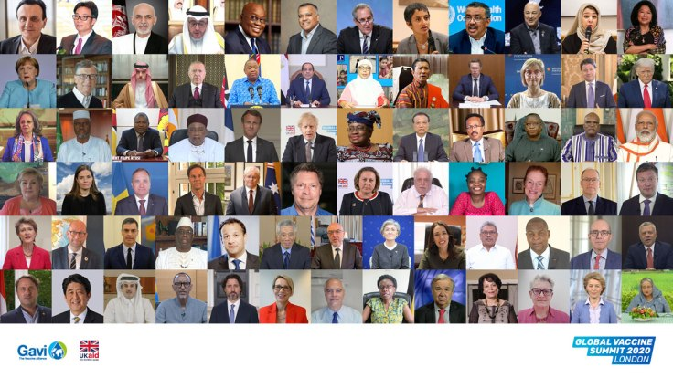](https://swprs.files.wordpress.com/2020/06/gvs-super-family-1200.jpg)Heads of government at the global vaccine summit on June 4, 2020 ( [GAVI](https://www.gavi.org/investing-gavi/resource-mobilisation-process/gavis-3rd-donor-pledging-conference-june-2020) )

**Medication against Covid-19**

The situation regarding helpful medication for severe Covid19 cases remains very unclear. The only consensus is that blood thinners are [helpful in](https://www.webmd.com/lung/news/20200506/blood-thinners-could-boost-covid19-survival) preventing life-threatening thrombosis and embolism (as with severe influenza).

There have been fierce discussions about the malaria drug hydroxychloroquin (HCQ) for months. The journal Lancet published a study at the end of May according to which HCQ leads to heart problems. The WHO then ceased all of its HCQ studies. Shortly thereafter, however, it became known that the Lancet study was based on [a manipulated data set](https://www.theguardian.com/world/2020/jun/03/covid-19-surgisphere-who-world-health-organization-hydroxychloroquine).

The Lancet study and another study in the *New England Journal of Medicine (NEJM)* had to be [withdrawn](https://www.bloomberg.com/news/articles/2020-06-04/researchers-retract-lancet-study-linking-malaria-drug-to-risks), which is one of the biggest medical scandals in recent years. The reason for the manipulated study is not clear, however, the lead author seems [to be involved](https://www.medicineuncensored.com/a-study-out-of-thin-air) in a study of competing drug Remdesivir at the same time.

The use of remdesivir by the pharmaceutical company Gilead came itself under pressure after [a first study showed](https://edition.cnn.com/2020/05/22/health/remdesivir-covid-19-trial-results-nejm-study/index.html) that the drug could not reduce the risk of death. However, many media ignored this and still reported positive about the drug.

A former French Minister of Health revealed [in an interview](https://www.youtube.com/watch?v=ZYgiCALEdpE) that the editors of Lancet and NEJM stated in a confidential discussion panel that the pressure and influence of pharmaceutical companies had become so great, indeed “criminal”, that one could no longer speak of science.

Various clinics [use or study](https://www.webmd.com/lung/news/20200409/chloroquine-zinc-tested-to-block-covid-infection) HCQ in Covid19 patients, sometimes in combination with zinc, vitamins or other medications. However, it is known that HCQ can lead to [fatal complications](https://off-guardian.org/2020/05/13/covid19-a-case-for-medical-detectives/) in people from Africa and the Mediterranean region that have a metabolic pecularity called favism.

Unfortunately, it must be assumed that incorrect or too aggressive medication with HCQ, [steroids](https://www.sciencedaily.com/releases/2020/02/200206110703.htm), antibiotics and antiviral agents as well as [invasive ventilation](https://nypost.com/2020/05/29/northwell-health-probing-use-of-ventilators-for-covid-patients/) has led to numerous additional and avoidable deaths during the corona pandemic.

**Expert opinions (selection)**

* The British chief medical officer **Dr. Chris Whitty**[explained in a lecture](https://off-guardian.org/2020/05/15/watch-uk-chief-medic-confirms-again-covid19-harmless-to-vast-majority/) that Covid19 posed “no danger to the vast majority of the population”. Most people do not or only mildly fall ill with it, and even with those who are seriously ill, the chances of recovery are good.
* Stanford professor and Nobel Laureate in Chemistry **Michael Levitt** explains [in a new article](https://www.telegraph.co.uk/news/2020/05/23/lockdown-saved-no-lives-may-have-cost-nobel-prize-winner-believes/) that the lockdowns did not save lives but cost many. A “panic virus” has spread among politicians worldwide, professor Levitt said.
* Professor **Karel Sikora** of the University of Buckingham argued [in an interview](https://www.youtube.com/watch?v=uk2YZfnsOPg) that ultimately, fear will “kill a lot more people than the virus,” including untreated heart and cancer patients. Schools should be opened quickly and masks should remain an individual decision because their benefits have not been proven. One should go back to an “old normal” and not a “new normal”. (**Note**: The video with Professor Sikora was temporarily deleted by YouTube and only restored after protests).
* **Professor Yoram Lass,** former director-general of Israel’s Ministry of Health, argues that the lockdown measures have been [“totally disproportionate”](https://www.spiked-online.com/2020/05/22/nothing-can-justify-this-destruction-of-peoples-lives/) and are an acute threat to hundreds of millions of people. Covid19 is “comparable to a flu epidemic” and would never have justified such political destruction of livelihoods. People have been intimidated and “brainwashed”.
* The Oxford professor of epidemiology, **Sunetra Gupta**, argues in a [new interview](https://unherd.com/2020/05/oxford-doubles-down-sunetra-gupta-interview/) that the lethality of Covid19 is likely to be below 0.1% and that a large number of people have already come into contact with the virus.
* Leading German virologist **Prof. Hendrik Streeck** criticized the lockdown [and explained that](https://www.welt.de/wissenschaft/article209299157/Corona-Krise-Virologe-Streeck-kritisiert-deutschen-Lockdown.html) “all experts are returning to the assessment of the early days” that Covid-19 “should not be trivialized, but also should not be dramatized”. The reason for the declining risk assessment was the “enormous number of infections that remained without symptoms”. Streeck does not expect any excess mortality in Germany by the end of the year, as the average age of death is “rather above life expectancy”, and he doesn’t consider “corona apps” and widespread corona tests to be useful. He also criticized the general use of masks, saying that these are a “wonderful breeding ground for bacteria and fungi”. Schools should be reopened as soon as possible.
* An **employee of the German Ministry of the Interior**, responsible for disaster protection, together with external experts wrote a [100-page analysis paper](https://www.ichbinanderermeinung.de/Dokument93.pdf) on corona crisis management, which was leaked to the press at the beginning of May and created [strong reactions](https://www.zeit.de/politik/deutschland/2020-05/corona-pandemie-bekaempfung-massnahmen-innenministerium-verschwoerungstheorien-regierungsrat/komplettansicht). In the paper, Covid-19 is described as a **“global false alarm”** because “there was probably at no time a risk beyond the normal level” for the general population. The collateral damage caused by the lockdown is now significantly higher than the recognizable benefit and far exceeds the risk potential of the corona virus. In March and April alone, over a million operations were not carried out in Germany. Crisis management and threat analysis mostly failed and data supplied by health authorities were “inadequate” as the basis for decision-making. The official was subsequently fired because he had created the paper “without authorization”.
* A group led by **Professor Sucharit Bhakdi founded** the Association of [Physicians and Scientists for Health, Freedom and Democracy](https://www.mwgfd.de/) (MWGFD), which has already been joined by over 16,000 supporters. At the beginning of June, the group published a [call to the federal government and all state governments](https://www.mwgfd.de/category/topaktuell/) to immediately and completely lift the Corona measures. Professor Bhakdi’s book, [Corona: A False Alarm?](https://www.amazon.de/Corona-Fehlalarm-Daten-Fakten-Hintergr%25C3%25BCnde/dp/3990601911), appearing at the end of June, is already an Amazon bestseller solely due to the pre-orders.
* A **senior physician for intensive medicine at the University Hospital Zurich**, who cared for critical Covid 19 patients, criticized in a [widely shared video](https://www.medinside.ch/de/post/corona-intensivmediziner-spricht-klartext) the “scaremongering” associated with the disease. For the vast majority of all people there is no significant risk of death, the numbers are comparable overall to earlier flu waves. Risk groups could be protected in a targeted manner, while the lockdown only prevents the immunization of the general population. In addition, people die due to the medical undersupply in other areas. The medical and social damage has long been greater than the benefits. The partially mandatory mouth protection for schoolchildren also has “no medical sense and benefit” and places a heavy burden on the children. The “daily counting” of the cases is nonsensical and only spreads fear. The counterproductive measures must be stopped quickly.Swiss media tried [to put pressure on](https://www.blick.ch/news/schweiz/unispital-distanziert-sich-von-umstrittenen-aussagen-corona-kritiker-feiern-videobotschaft-von-zuercher-oberarzt-id15903859.html) the Zurich University Hospital after the video had been widely distributed. The doctor has since removed the original video.
* The Swiss chief physician for infectiology, **Dr. Pietro Vernazza**, using current case studies as an example, [explains](https://infekt.ch/2020/05/expedition-mit-ueberraschendem-ausgang-ein-epidemiologisches-lehrstueck/) that fever measurements and contact tracing are not useful due to the often symptom-free course and easy transmission of Covid19.
* The well-known Swiss immunologist **Dr. Beda Stadler** explains [in an article](https://www.swissinfo.ch/ita/seconda-ondata-con-lockdown--in-svizzera-no-di-sicuro/45797198) that Covid19 is a “very selective disease” and only poses a real risk for very few people. The media, on the other hand, focused on the few atypical individual cases that exist with every illness. Many scientists had focused too much on their models and too little on reality. The planned contact tracing is medically “senseless” and [spreads](https://www.blick.ch/news/schweiz/behoerden-und-experten-raetseln-wo-ist-das-virus-hin-id15915001.html) “only panic”.
* **Overview**: [250 worldwide expert voices against corona dogmas](https://www.rubikon.news/artikel/weltweiter-widerstand) (German)

**Success stories**

**Sweden**: Sweden had no lockdown, no mask requirement and no primary school closures, but instead mainly relied on the personal responsibility and cooperation of the population. This approach [worked well](https://www.nationalreview.com/2020/05/coronavirus-crisis-sweden-refused-lockdown-other-countries-following/) and Sweden saw only a low mortality rate in the general population, comparable to a seasonal flu wave.

Nevertheless, the overall mortality rate in Sweden was indeed [higher than](https://www.statista.com/statistics/1104709/coronavirus-deaths-worldwide-per-million-inhabitants/) in the neighboring Scandinavian countries or in Germany, which was portrayed by many international media as an alleged “failure of the Swedish no-lockdown strategy”.

However, most media didn’t mention that [three quarters of Swedish deaths](https://www.thelocal.se/20200525/swedish-death-toll-passes-4000-as-coronavirus-cases-in-care-homes-start-to-fall) occured in nursing facilities, which require targeted protection and do not benefit from a general lockdown of society. Indeed, at 86 years, the median age of Swedish Covid deaths is likely the highest in the world.

The Swedish government has also been one of the few to apologize for the insufficient protection of nursing patients and to announce an investigation, but this has again [been portrayed](https://www.spiked-online.com/2020/06/08/no-sweden-has-not-changed-its-mind-about-lockdown/) by many media as an alleged “failure of the Swedish no-lockdown strategy”.

Yet even total mortality in Sweden remained [below the strongest seasonal flu waves](https://www.reuters.com/article/us-health-coronavirus-sweden-toll/coronavirus-pushes-swedish-deaths-to-highest-since-1993-in-april-idUSKBN22U1S4) of the past thirty years. Moreover, Sweden may now benefit from a very high [natural immunity](https://medicalxpress.com/news/2020-05-stockholm-virus-antibodies-sweden.html), especially in view of the latest immunological studies on the actual range of antibody tests (see above).

[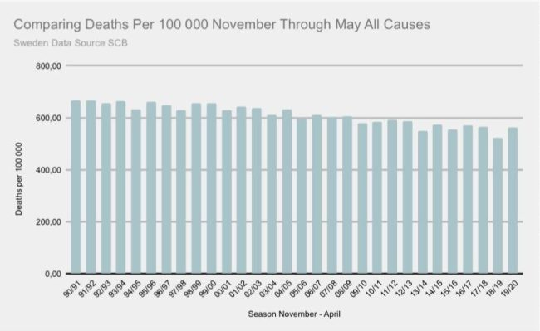](https://swprs.files.wordpress.com/2020/06/sweden-mortality-comparison-1990-e1591998033581.jpg)Sweden: All-cause mortality, November to May, since 1990 ([SCB/Twitter](https://twitter.com/HaraldofW/status/1270080210545733632))

**Florida**: Despite being home to many senior citizens, Florida introduced rather few restrictions and even the popular beaches were reopened early, which was heavily criticized by many US media. Nevertheless, Florida [did very well](https://www.statista.com/statistics/1109011/coronavirus-covid19-death-rates-us-by-state/) compared to other states and recently had around [2300 deaths in a](https://www.clickorlando.com/news/local/2020/03/16/interactive-map-shows-florida-coronavirus-cases-in-real-time/) population of 21 million, which corresponds to Germany’s low mortality.

In an interview, the governor [explained that](https://www.nationalreview.com/2020/05/coronavirus-crisis-ron-desantis-florida-covid-19-strategy/) contrary to the media, he realized early on based on the figures from South Korea and Italy that Covid19 was only dangerous for a very small risk group and he therefore protected the nursing homes as best as possible. In terms of prevention, nursing homes were even more important than the clinics themselves, and this strategy had proven itself. At the end of May, the governor announced that summer camps and youth activities could [be carried out without restrictions](https://www.usnews.com/news/best-states/florida/articles/2020-05-22/miami-beach-officials-agree-to-reopen-hotels-beaches-june-1).

**Japan**: Japan registered some of the first Covid19 cases outside of China, but did not introduce a lockdown. At the end of March, the Japan Times asked, [“Where’s the coronavirus explosion?”](https://www.japantimes.co.jp/news/2020/03/20/national/coronavirus-explosion-expected-japan/) Bloomberg now reports that a corona crisis [never materialized](https://www.bloomberg.com/news/articles/2020-05-22/did-japan-just-beat-the-virus-without-lockdowns-or-mass-testing): there were no restrictions on movement, restaurants and hairdressers remained open, there were no “tracking apps” and no mass tests of the general population. Nevertheless – or because of this – Japan now has by far the least deaths compared to the G7 industrialized countries.

It is sometimes argued that the respirators were decisive for Japan’s success. However, respirators are voluntary in Japan and did not stop the outbreak in the Chinese city of Wuhan, while Sweden, Florida and other successful regions did not use masks in the general population.

**Belarus**: Belarus has probably implemented the least restrictions of all industrialized nations and [carried out](https://www.youtube.com/watch?v=NZliKGoUN4E) even major events such as the 75-year celebrations of the end of World War II. Nevertheless, Belarus officially counts fewer than [300 Covid deaths](https://en.wikipedia.org/wiki/COVID-19_pandemic_in_Belarus) even after more than three months. Long-term President Lukashenko, who has repeatedly referred to Corona as a “psychosis,” said in mid-May that the capital, Minsk, had already [passed](https://eng.belta.by/president/view/belarus-president-coronavirus-situation-on-the-mend-130571-2020/) the peak. The decision to treat Covid19 cases like normal pneumonia was correct. Ultimately, however, only statistics on overall mortality will be able to show whether the Belarusian numbers are really correct.

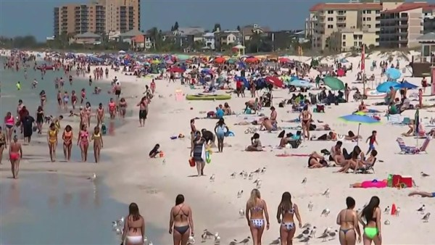A Florida beach during the Corona pandemic ([NBC](https://www.nbcnews.com/news/us-news/coronavirus-comes-spring-break-locals-close-florida-beaches-after-governor-n1163741))

**Additional Notes**

* **Transmission routes**: A new report by the US health agency CDC comes [to the conclusion](https://www.yahoo.com/lifestyle/cdc-coronavirus-mainly-spreads-through-persontoperson-contact-and-does-not-spread-easily-on-contaminated-surfaces-153317029.html) that the virus is transmitted primarily through direct contact with people and “cannot spread easily on surfaces.” The German virologist Hendrik Streeck [was](https://www.telegraph.co.uk/news/2020/04/02/no-proof-coronavirus-can-spread-shopping-says-leading-german/) already [able to demonstrate](https://www.telegraph.co.uk/news/2020/04/02/no-proof-coronavirus-can-spread-shopping-says-leading-german/) that the new corona virus does not or hardly spread through objects or through aerosols floating in the air.
* **Distance rules**: Iceland [declared the](https://icelandmonitor.mbl.is/news/news/2020/05/25/two_meter_rule_optional_in_iceland/) distance rules optional at the end of May and reopened bars and clubs. Switzerland converted the distance regulations into a voluntary [recommendation](https://www.20min.ch/story/bund-schafft-die-2-meter-abstands-busse-heimlich-ab-763738047957). A [Cochrane study from 2011](https://www.cochranelibrary.com/cdsr/doi/10.1002/14651858.CD006207.pub4/full) already showed that there is so far hardly any evidence for the effectiveness of “social distancing” measures.
* **Surgeries**: According to an article in the British Journal of Surgery, [around 28 million surgeries](https://bjssjournals.onlinelibrary.wiley.com/doi/abs/10.1002/bjs.11746), including many cancer surgeries, have been canceled or postponed worldwide over 12 weeks due to corona measures.
* **Years of life**: An evaluation by four US professors comes to the conclusion that the lockdown in the USA will cost about [twice as many years of life](https://thehill.com/opinion/healthcare/499394-the-covid-19-shutdown-will-cost-americans-millions-of-years-of-life) as Covid-19 and was therefore a very counterproductive measure even from a purely medical point of view.
* **Coronavirus season:** A [new study in the Journal of Infectious Diseases](https://academic.oup.com/jid/advance-article/doi/10.1093/infdis/jiaa161/5815743) shows that coronaviruses occur “sharply seasonal” between December and April / May.
* **Virus test**: A German mathematician explains why the low remaining infection **numbers** in many countries consist largely of [false positive results](https://multipolar-magazin.de/artikel/warum-die-pandemie-nicht-endet), even with fairly accurate PCR tests, and the pandemic thus “never seems to end”.
* **“Second wave”**: Studies on a “second wave” sometimes make [completely unrealistic assumptions](https://www.heise.de/tp/features/Fellay-Studie-Zweite-Corona-Welle-4726303.html), such as a constant risk of infection and death across all age groups. Nevertheless, the example of the [1968 Hong Kong flu](https://www.britannica.com/event/Hong-Kong-flu-of-1968) shows that the global spread of pandemics can indeed extend over several seasons.
* **Italy**: [Almost 5% of the population](https://www.medrxiv.org/content/10.1101/2020.05.11.20098442v2) in Milan already had antibodies against Covid19 in mid-February, ie before the outbreak of the epidemic in Italy. This again indicates that the virus was already circulating in Europe earlier than previously thought.
* **Unemployment**: The International Labor Agency ILO expects that due to the political corona measures, half of the world’s employees or 1.6 billion people are at [risk of losing their livelihoods](https://www.theguardian.com/world/2020/apr/29/half-of-worlds-workers-at-immediate-risk-of-losing-livelihood-due-to-coronavirus).
* **Fact check**: [13 misleading and false claims about the corona epidemic](https://www.infosperber.ch/Artikel/Gesundheit/13-irrefuhrende-und-falsche-Behauptungen-zur-Corona-Epidemie) (German)
* **Review**: Why life went on as normal during the global flu pandemics [of 1968/1969](https://nypost.com/2020/05/16/why-life-went-on-as-normal-during-the-killer-pandemic-of-1969/) (Hong Kong flu, and the Woodstock music festival) and [of 1957](http://www.ronpaulinstitute.org/archives/featured-articles/2020/may/06/the-great-pandemic-of-1957-and-why-nobody-remembers-it/) (Asian flu).

**Did the lockdowns save lives?**

Many media reported on a study by Imperial College London, according to which the lockdowns in Europe allegedly [“saved 3 million lives”](https://www.bbc.com/news/health-52968523). In reality, Imperial College London simply compared the [unrealistic predictions](https://www.telegraph.co.uk/technology/2020/05/16/neil-fergusons-imperial-model-could-devastating-software-mistake/) of its own model with actual developments. This is particularly evident in the case of Sweden, which even without a lockdown had only a fraction of the deaths predicted by the Imperial College model (see graph).

[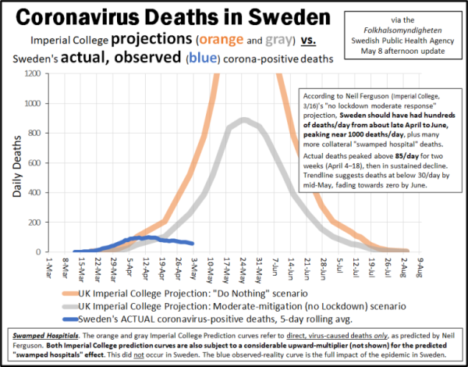](https://swprs.files.wordpress.com/2020/06/coronavirus-deaths-in-sweden-actual-deaths-vs-ferguson-projections-may-8-update.png)Imperial College model vs. reality in Sweden. **Orange**: prediction without measures; **grey**: prediction with moderate measures; **blue**: reality. (GRC; May 8, 2020)

**The role of the media**

Most traditional media, almost all of which are part of [elite geopolitical networks](https://swprs.org/the-american-empire-and-its-media/), decided to run a campaign of fear during the coronavirus period, a behavior that is usually observed in connection with [wars of](https://www.infosperber.ch/Artikel/Gesundheit/13-irrefuhrende-und-falsche-Behauptungen-zur-Corona-Epidemie) [aggression](https://swprs.org/the-syria-deception/) or alleged [terrorist attacks](https://www.motherjones.com/politics/2013/01/terror-factory-fbi-trevor-aaronson-book/).

The risk to the general population was greatly [exaggerated](https://www.infosperber.ch/index.cfm%3Fgo%3DArtikel/Gesundheit/13-irrefuhrende-und-falsche-Behauptungen-zur-Corona-Epidemie/%26g%3Dad), official policies were [hardly questioned](https://www.zora.uzh.ch/id/eprint/186723/1/jarren_corona.pdf), the situation in hospitals was [dramatized](https://www.globalresearch.ca/truth-behind-refrigerated-morgue-truck-stories/5711475), manipulative images were [used](https://nypost.com/2020/04/01/cbs-admits-to-using-footage-from-italy-in-report-about-nyc/), campaigns were [staged](https://www.youtube.com/watch?v=oQWRCECbN-Y), and protesters were systematically defamed as “idiots”.

It is true that some conservative media criticized the economically harmful lockdown measures. The real question, however, is whether they will also criticize the surveillance measures now planned, such as the extensive societal contact tracing (see below).

Most [independent media](https://swprs.org/media-navigator/) sooner or later realized that the risk of the corona virus was exaggerated and politically exploited. Only a few independent media outlets did not realize this, perhaps because they lacked a medical background or fell for the official campaign of fear.

Some analysts compared Covid-19 [to a psychological operation](https://digwithin.net/2020/06/03/coronavirus-scare/) that uses the media-induced fear of the virus to bring about political and social change.

US platforms such as Google, Youtube, Facebook and Twitter [censored](https://nypost.com/2020/05/16/youtube-censors-epidemiologist-knut-wittkowski-for-opposing-lockdown/) corona issues extensively by deleting critical (i.e. non WHO compliant) points of view even from doctors or restricting their distribution, a procedure that has long been the norm for geopolitical issues.

However, modern media users have the option of using manipulation-free search engines such as DuckDuckGo and independent video platforms such as Bitchute, as well as generally using an advertising and tracking blocker on certain media sites.

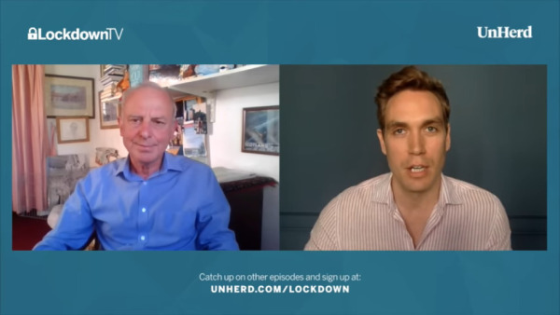A contrarian interview with Prof. Karel Sikora that was temporarily deleted by Youtube ([Unherd](https://www.youtube.com/watch?v=uk2YZfnsOPg))

**Political developments**

Numerous observers have already drawn attention to the fact that the predominantly politically induced “corona crisis” is or could be instrumentalized for far-reaching social and economic changes.

In March, NSA whistleblower **Edward Snowden** warned that governments are using the temporary corona crisis as an occasion or pretext for the permanent expansion of [social surveillance and control](https://www.youtube.com/watch?v=-pcQFTzck_c), thereby establishing an “architecture of oppression”.

The measures currently being discussed or already implemented include in particular:

1. The introduction of applications for **society-wide contact tracing**
2. Building **units to enforce** tracing and isolation of citizens
3. The introduction of digital **biometric ID cards** that can be used to control and regulate participation in social and professional activities.
4. The expanded control of **travel and payment transactions** (e.g. cash abolition).
5. The creation of legal foundations for access to the **biological systems** of citizens by governments or corporations (through so-called “mandatory vaccinations”).

More than 600 scientists [have warned of](https://www.esat.kuleuven.be/cosic/sites/contact-tracing-joint-statement/) an “unprecedented surveillance of society” through problematic apps for “contact tracing”. In some countries, such “contact tracing” is already carried out directly [by the secret service](https://www.jewishpress.com/news/the-courts/state-to-high-court-even-more-shin-bet-involvement-in-fighting-the-coronavirus/2020/04/14/). In several parts of the world, the population is already being [monitored by drones](https://off-guardian.org/2020/04/25/50-headlines-darker-more-of-the-new-normal/) and facing serious police overreach.

In May, **Apple and Google added** a contact tracing interface to the operating systems of [three billion cell phones](https://www.bloomberg.com/news/articles/2020-04-10/apple-google-bring-covid-19-contact-tracing-to-3-billion-people) that can now be used by national authorities.

This is despite the fact that a recent WHO study on pandemic influenza came to the conclusion that contact tracing is not sensible from a medical point of view and is [“not recommended in any circumstances”](https://apps.who.int/iris/bitstream/handle/10665/329438/9789241516839-eng.pdf), as the epidemiological benefits of such apps remain doubtful.

It is often argued that the contact tracing applications would remain “voluntary” and “compliant with data protection”. However, in practice, neither is really true.

In several countries, the use of the applications is already mandatory for certain activities. Various employers, administrations, landlords and transport companies in **India** require [the tracing app](https://www.technologyreview.com/2020/05/07/1001360/india-aarogya-setu-covid-app-mandatory/). In **Argentina**, everyone who is in the “public space” must [activate contact tracing](https://www.heise.de/tp/features/CuidAR-Argentinien-ueberwacht-mit-einer-App-4720143.html).

Some **German politicians** already advocated a [preference for app users](https://www.faz.net/aktuell/politik/wer-die-corona-app-hat-soll-zuerst-wieder-ins-restaurant-duerfen-16759932.html) when traveling or dining out. The **Israeli Prime Minister** Netanyahu, for his part, spoke of the [use of “sensors”](https://norberthaering.de/die-regenten-der-welt/netanyahu-sensoren/) for distance control in children.

In **Singapore**, the “voluntary” app was installed by fewer people than expected, which is why the government now wants to make it [mandatory](https://www.letemps.ch/economie/singapour-tracage-app-degenere-surveillance-masse) for certain public spaces and services. In some parks, the distance control is already [monitored by DARPA robots](https://www.youtube.com/watch?v=2DJmIjKtVkA).

In **Australia**, people who do not want to use the contact tracing app are insulted by the media [as idiots and a danger to the public](https://www.news.com.au/world/coronavirus/australia/people-who-refuse-to-download-the-covidsafe-virus-tracing-app-are-the-new-antivaxxers/news-story/541c36fe5cdb56eb1a098b0b9a0dddcc), and are thus put under social pressure.

Singapore: A DARPA robot dog monitoring social distancing ([CNA](https://www.youtube.com/watch?v=2DJmIjKtVkA))

The **data protection of** the supposedly “decentralized” contact tracing is also problematic. The Dutch IT professor Jaap-Henk Hoepmann [already explained in April](http://blog.xot.nl/2020/04/11/stop-the-apple-and-google-contact-tracing-platform-or-be-ready-to-ditch-your-smartphone/) that even supposedly decentralized solutions can very easily be used for monitoring and surveillance.

Due to the speed of the introduction, the President of the German Society for Computer Science suspected that the functions [“had long been in the devices”](https://www.heise.de/news/Informatiker-Die-Corona-App-ist-wie-ein-trojanisches-Pferd-4764560.html) and only a little “fine tuning” was required. He sees the apps as a **“Trojan horse”**.

In parallel to the introduction of the applications, many countries have started to set up **special units to track contacts and isolate citizens**.

In the **United States** a [100 billion-dollar legislation](https://heavy.com/news/2020/05/hr-6666-trace-bill-bobby-rush/) to set up a national “Corona testing and tracing corps” with up to [180,000 members](https://www.washingtonpost.com/opinions/2020/05/29/corona-corps-could-fight-virus-youth-unemployment/) has been proposed. The states of [New York](https://www.jhsph.edu/news/news-releases/2020/johns-hopkins-and-bloomberg-philanthropies-with-new-york-state-launch-online-course-to-train-army-of-contact-tracers-to-slow-spread-of-COVID-19.html) and [California](https://timesofsandiego.com/tech/2020/05/06/california-training-a-20000-person-army-of-coronavirus-tracers/) are already building “contact tracing armies” with up to 20,000 members each. In the state of [Washington](https://lynnwoodtimes.com/2020/05/12/governor-inslee-lays-out-statewide-contact-tracing-plan-for-covid-19/), the National Guard is to participate and those who do not cooperate “voluntarily” can be forced to do so.

**Italy has** announced the creation of a corps [with 60,000 volunteers](https://www.thelocal.it/20200525/italy-seeks-60000-volunteers-to-enforce-coronavirus-rules), and [Switzerland](https://www.nzz.ch/zuerich/coronavirus-in-zuerich-contact-tracing-ist-gut-angelaufen-ld.1556846) and other countries have also started building such units. In **Germany** there have already been mass tests in residential buildings under the threat of [police coercion](https://www.youtube.com/watch?v=6ZQFpnskP8g).

The **software** for society-wide contact tracing in the USA, [Great Britain](https://www.telegraph.co.uk/technology/2020/05/16/inside-story-cia-backed-palantir-embedded-nhs-socialite-running/) and possibly in other European countries is provided by the [CIA-related technology company Palantir of](https://techcrunch.com/2020/04/01/palantir-coronavirus-cdc-nhs-gotham-foundry/) US billionaire Peter Thiel. In Israel, contact tracing software from notorious cyber spy company NSO [is used](https://www.techdirt.com/articles/20200402/14261944226/controversial-spyware-vendor-nso-group-is-helping-israeli-government-spy-own-citizens.shtml).

A **whistleblower** who [took part](https://www.youtube.com/watch?v=qFUyZWw7qoc) in a training program for contact tracers in the United States described it in a video interview as “totalitarian” and a “danger to society”.

All these measures are taken despite the fact that the epidemiological benefit remains unclear and that the WHO [explicitly opposed](https://apps.who.int/iris/bitstream/handle/10665/329438/9789241516839-eng.pdf) contact tracing, which is otherwise used mainly for serious sexual diseases or food poisoning, which, unlike common respiratory diseases, are easy to trace.

In addition to applications and special units for contact tracing, there are also specific [projects or plans](https://www.msn.com/en-us/news/world/the-uk-government-is-in-talks-with-facial-recognition-firms-to-develop-covid-19-immunity-passports/ar-BB12J6It) for **“immunity cards”**, which could be used, for example, to control the travel and work activities of the population. In fact, the EU [had been](https://off-guardian.org/2020/05/22/report-eu-planning-vaccination-passport-since-2018/) planning to introduce such a vaccination certificate [since 2018](https://off-guardian.org/2020/05/22/report-eu-planning-vaccination-passport-since-2018/).

Such “vaccination cards” are in turn linked to a worldwide **“vaccination program”**, which is also currently being worked on. For example, US billionaire and vaccine investor Bill Gates called for corona vaccination for [“seven billion people”](https://www.businessinsider.com/bill-gates-14-billion-doses-coronavirus-vaccine-may-be-needed-2020-5). AstraZeneca is currently preparing to produce [two billion doses of](https://www.sciencealert.com/2-billion-doses-of-oxford-s-potential-coronavirus-vaccine-could-soon-become-available) the still untested Oxford vaccine.

From a strategic point of view, such a global vaccination programme would provide access to the biological systems of the population, in particular the immune and nervous systems and the genetic and reproductive systems.

In the **economic area**, there is a surge in digitization and centralization in favor of a few US technology corporations, as the *American National Security Commission on Artificial Intelligence (NSCAI)*, led by former Google CEO Eric Schmidt, [demanded in a strategy paper](https://thelastamericanvagabond.com/top-news/techno-tyranny-how-us-national-security-state-using-coronavirus-fulfill-orwellian-vision/) in 2019 to be able to compete with China.

The **World Economic Forum (WEF)** Davos, which together with the Gates Foundation and Johns Hopkins University already ran the well-known [coronavirus pandemic exercise “Event 201”](https://www.centerforhealthsecurity.org/event201/scenario.html) in October 2019, called for a global [“Great Reset”](https://www.youtube.com/watch?v=u5pxhSnDr4U) in order prepare the economic and social structures for the 21st century.

Meanwhile, several cardinals and bishops of the **Catholic Church** warned in an [open letter](https://veritasliberabitvos.info/appeal/) that, under the pretext of the coronavirus, a worldwide panic had been triggered to introduce “unacceptable forms of global surveillance and control” of the population.

The idea that a pandemic can be used to expand global monitoring and control is not new. As early as 2010 the American **Rockefeller Foundation** described in a [working paper on future technological and social developments](https://swprs.files.wordpress.com/2020/04/rockefeller-foundation-scenarios-2010.pdf) a “lockstep scenario” in which the present-day developments were anticipated with surprising accuracy (from page 18).

But there are also reactions from the population: [Spain](https://www.youtube.com/watch?v=BZo3BYD2qpI), [Italy](https://www.youtube.com/watch?v=P2Tcs8RzK1k) and [Germany](https://www.youtube.com/watch?v=Iqm456JIaBQ), for example, have seen demonstrations for fundamental rights with thousands or tens of thousands of people.

**See also**: [Inside the NSA’s Secret Tool for Mapping Your Social Network](https://www.wired.com/story/inside-the-nsas-secret-tool-for-mapping-your-social-network/) (Wired)

**Creative contributions**

* Video: [They Live – Coronavirus Edition](https://www.youtube.com/watch?v=xikn9JNu4Ag) (Trigger Happy Media)
* Video: [Out of Touch – Run for your life](https://www.youtube.com/watch?v=wfGAktuU93s) (Kevin James)
* Video: [What It’s Like to Believe Everything the Media Tells You](https://www.youtube.com/watch?v=QcUAG6t5aN8) (JP)

[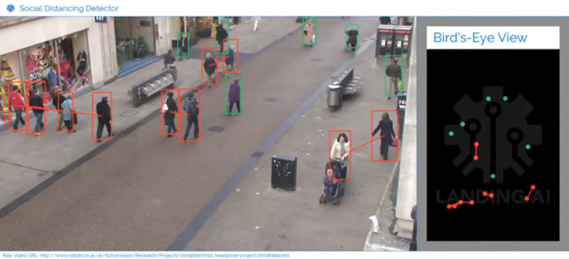](https://swprs.files.wordpress.com/2020/06/landing-ai-social-distancing-detector.jpg)The Landing AI Social Distancing Detector ([Youtube](https://landing.ai/landing-ai-creates-an-ai-tool-to-help-customers-monitor-social-distancing-in-the-workplace/))

**B. Countries and regions**

**Scandinavia**

* **Denmark**: In Denmark, leaked emails revealed that, contrary to political statements, the health authority [spoke out *against* a lockdown](https://www.thelocal.dk/20200529/leaked-emails-show-how-denmarks-pm-steam-rollered-her-own-health-agency) in March and wrote: “ The Danish health authority continues to believe that Covid-19 cannot be described as a generally dangerous disease because it’s neither normally serious, nor does it have a high mortality rate. ” In addition, a lower reproduction number was not published for political reasons to justify the lockdown. The Danish parliament has now decided to investigate government policy by an expert commission.
* **Norway**: The Prime Minister of Norway [publicly admitted](https://www.telegraph.co.uk/news/2020/05/30/coronavirus-norway-wonders-should-have-like-sweden/) that she panicked in March and that most of the lockdown measures would probably not have been necessary. In Norway, too, it became known that the reproduction number already fell to the stable value of 1 before the lockdown. In the case of a “second wave”, a much softer strategy without lockdown would have to be chosen, the Prime Minister declared.
* **Sweden**: Despite enormous international pressure, Sweden managed the Corona period well without a lockdown and overall mortality remained in the range of [earlier strong flu waves](https://www.reuters.com/article/us-health-coronavirus-sweden-toll/coronavirus-pushes-swedish-deaths-to-highest-since-1993-in-april-idUSKBN22U1S4). 75% of deaths occurred in nursing homes and nursing apartments, an issue the government promised to [investigate](https://www.bloomberg.com/news/articles/2020-05-08/sweden-starts-criminal-probe-into-care-home-after-virus-deaths). International media tried to portray this as “failure of the Swedish no-lockdown strategy”, which of couse is not correct, as nursing homes need targeted protection and do not benefit from a general lockdown of society.
* **Schools**: Both Finland and Denmark saw [no increase](https://www.telegraph.co.uk/news/2020/06/04/no-rise-finlands-coronavirus-infection-rate-since-schools-reopened/) in Corona cases after their schools reopened. Sweden kept its primary schools open to begin with.

**United States**

* There were approximately 100,000 test-positive deaths in the United States by the end of May. The **overall mortality rate** since the beginning of the year was, however, in the range of the strong flu season of 2017/2018 (see chart below).
* At least [42% of deaths](https://www.forbes.com/sites/theapothecary/2020/05/26/nursing-homes-assisted-living-facilities-0-6-of-the-u-s-population-43-of-u-s-covid-19-deaths/) occurred in nursing homes, which account for 0.6% of the U.S. population and did not benefit from a general lockdown.
* In the states that **did not implement a lockdown** or removed it early, there was [no increased mortality,](https://www.dailymail.co.uk/news/article-8347635/Lockdowns-failed-alter-course-pandemic-JP-Morgan-study-claims.html) according to a study by JP Morgan.
* An evaluation by four US professors comes to the conclusion that the lockdown in the US will cost about [twice as many years of life](https://thehill.com/opinion/healthcare/499394-the-covid-19-shutdown-will-cost-americans-millions-of-years-of-life) as Covid-19.
* In an [open letter](https://www.washingtonexaminer.com/news/mass-casualty-incident-over-600-doctors-sign-letter-warning-trump-of-dangers-of-continued-lockdowns), over 600 doctors warned US President **Donald Trump of** the dangers of an extended lockdown. The lockdown was itself a “mass casualty incident”.
* In another [open letter](https://aapsonline.org/physician-letter-reopen-america/) to US Vice President **Mike Pence,** American doctors are calling for the rapid opening of society. The dangerousness of Covid-19 turned out to be much less than originally assumed. The risk groups are known and can be protected in a targeted manner. A safe immunization of society is also possible without vaccination. The media has terrorized the population unnecessarily, triggering a sharp rise in despair and suicides.
* Most of the U.S. Army’s **field hospitals,** which were built for a total of $ 660 million, [closed](https://www.npr.org/2020/05/07/851712311/u-s-field-hospitals-stand-down-most-without-treating-any-covid-19-patients) again in May without treating even a single patient.
* A California trauma doctor said [in a post](https://www.dailymail.co.uk/news/article-8347011/Doctors-California-say-people-killed-four-weeks-YEAR.html) that there were more **suicide attempts** in May than usually in a year, and that the suicides far outnumbered the corona deaths in California.
* In the severely affected state of **New York**, an [independent investigation was requested](https://nypost.com/2020/05/12/calls-for-independent-probe-of-gov-cuomos-nursing-home-policies/) regarding the official order for **nursing homes to** admit Corona patients. There were over 5000 deaths in New York nursing homes. Such orders were also issued in the heavily affected states of New Jersey and Pennsylvania.
* New York’s largest hospital association has announced an [investigation into the use of](https://nypost.com/2020/05/29/northwell-health-probing-use-of-ventilators-for-covid-patients/) invasive **ventilators**. In April, it was confirmed that US hospitals [receive large bonuses](https://eu.usatoday.com/story/news/factcheck/2020/04/24/fact-check-medicare-hospitals-paid-more-covid-19-patients-coronavirus/3000638001/) when they admit Covid-19 patients and connect them to ventilators, although experts long before [warned of](https://off-guardian.org/2020/05/06/covid19-are-ventilators-killing-people/) the dangers of invasive ventilation. A New York nurse even spoke of a [“mass murder”](https://nypost.com/2020/05/29/northwell-health-probing-use-of-ventilators-for-covid-patients/).
* In the state of Washington [,](https://www.freedomfoundation.com/washington/washington-health-officials-gunshot-victims-counted-as-covid-19-deaths/) the health agency [confirmed](https://www.freedomfoundation.com/washington/washington-health-officials-gunshot-victims-counted-as-covid-19-deaths/) that even **homicide victims** were counted as “corona deaths” if they tested positive for the corona virus. The New York Times also listed [a murder victim on their](https://www.washingtontimes.com/news/2020/may/24/new-york-times-lists-homicide-victim-coronavirus-d/) front page of alleged “Corona victims”. Even **George Floyd**, who was killed by a police officer at the end of May, [tested positive](https://www.nydailynews.com/coronavirus/ny-coronavirus-george-floyd-20200604-pvhrtjn4mna5blzow3gfx5ag3y-story.html) for Corona.
* By the end of May, [over 40 million people](https://www.businessinsider.com/us-weekly-jobless-claims-unemployment-filings-coronavirus-labor-market-layoffs-2020-5) had been **unemployed** in the United States. Estimates predict that around 42% of lost jobs will [not be recovered](https://www.forbes.com/sites/kenrapoza/2020/05/15/some-42-of-jobs-lost-in-pandemic-are-gone-for-good/) and that the worst recession since World War II is imminent (see chart below). Nevertheless, **US billionaires** saw corona add [$ 434 billion to](https://www.cnbc.com/2020/05/21/american-billionaires-got-434-billion-richer-during-the-pandemic.html) their wealth.

[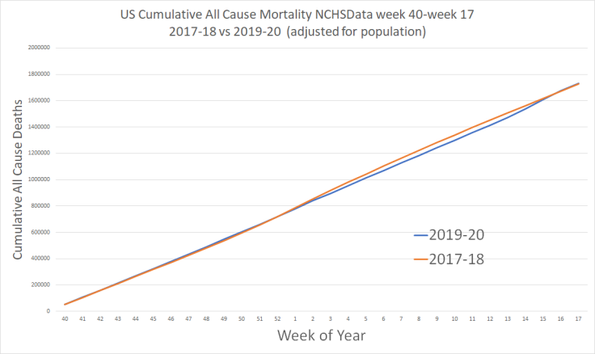](https://swprs.files.wordpress.com/2020/06/us-cumulative-deaths.png)USA: Gesamtsterblichkeit 2017/18 und 2019/2020 (population adjusted). Source: [NCHS/Twitter](https://twitter.com/boriquagato/status/1267174557976166402) [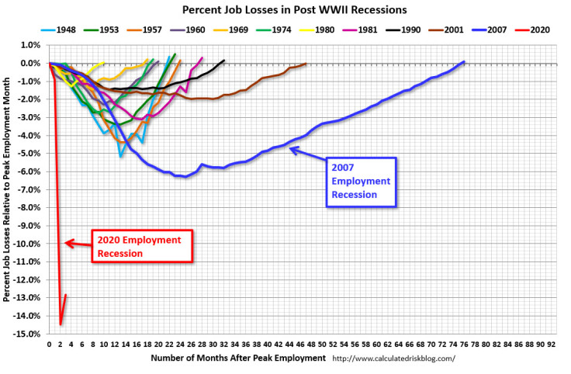](https://swprs.files.wordpress.com/2020/06/us-2020-recession.jpg)USA: Job loss in recessions since 1945 ( [BLS / CRB](https://www.calculatedriskblog.com/2020/06/may-employment-report-2500000-jobs.html) )

**Great Britain**

* In March and April, England and Wales experienced an [excess mortality](https://www.ons.gov.uk/peoplepopulationandcommunity/birthsdeathsandmarriages/deaths/articles/analysisofdeathregistrationsnotinvolvingcoronaviruscovid19englandandwales28december2019to1may2020/technicalannex) of about 46,000 people. This roughly corresponds to [the strong flu waves](https://off-guardian.org/2020/05/25/were-all-in-the-big-numbers-now/) of 1999 and 2000 (see graphic below). However, the health authority ONS notes that almost 30% of this mortality is [not due to the coronavirus](https://www.ons.gov.uk/peoplepopulationandcommunity/birthsdeathsandmarriages/deaths/articles/analysisofdeathregistrationsnotinvolvingcoronaviruscovid19englandandwales28december2019to1may2020/technicalannex).
* For example, by early May, [8,000 more people](https://www.theguardian.com/society/2020/may/08/more-people-dying-at-home-during-covid-19-pandemic-uk-analysis) died at home than usual, and 80% of these deaths, according to death certificates, had nothing to do with the corona virus.
* In British **nursing homes** alone, there were 30,000 excess deaths by the beginning of May, of which only 10,000 cases noted Covid-19 as the cause on the death certificate, as Cambridge professor David Spiegelhalter [explained](https://www.bmj.com/content/369/bmj.m1931). In England and Wales, around [10,000 additional dementia patients](https://www.theguardian.com/world/2020/jun/05/covid-19-causing-10000-dementia-deaths-beyond-infections-research-says) *without* corona infection died in April due to weeks of isolation.
* Similar to northern Italy and New York, in England there was a [fatal decision](https://drmalcolmkendrick.org/2020/05/11/how-to-make-a-crisis-far-far-worse/) to move corona patients from hospitals **to nursing homes**, and the coronavirus was also spreading rapidly within the healthcare system itself.
* Most of the additional Covid **field hospitals that** were built remained [largely empty](https://www.telegraph.co.uk/news/0/do-many-nhs-nightingale-hospitals-remain-empty/).
* The influential epidemiologist **Neil Ferguson’s** computer model, which predicted hundreds of thousands of deaths, was found to be [highly flawed and unrealistic](https://www.telegraph.co.uk/technology/2020/05/16/neil-fergusons-imperial-model-could-devastating-software-mistake/) in an independent analysis by software and modeling experts. Ferguson had to resign as a government [adviser](https://www.telegraph.co.uk/news/2020/05/05/exclusive-government-scientist-neil-ferguson-resigns-breaking/) after breaking the lockdown himself to visit his married lover. Based on his failed model, his university now claims that the lockdown [“saved three million lives”](https://www.bbc.co.uk/news/health-52968523) in Europe.
* **Analysis**: [Who controls the British Government response to Covid-19?](https://www.ukcolumn.org/article/who-controls-british-government-response-covid19-part-one) (Part 1) and [COVID-19: The Big Pharma players behind UK Government lockdown](https://www.ukcolumn.org/article/covid%E2%80%9319-big-pharma-players-behind-uk-government-lockdown) (Part 2)
* UK economic experts predict the [biggest economic recession](https://twitter.com/FinancialTimes/status/1258499372251328515) since the Great Frost of 1709 (in the Little Ice Age).
* **Positive anecdote**: Britain’s oldest tailor [survived the corona virus](https://www.yorkpress.co.uk/news/18449261.oldest-working-tailor-uk-elwyn-96-beats-coronavirus/) at the age of 96 after not eating for ten days.
* **More UK Covid statistics** on [Covid-19 In Proportion](http://inproportion2.talkigy.com/).

[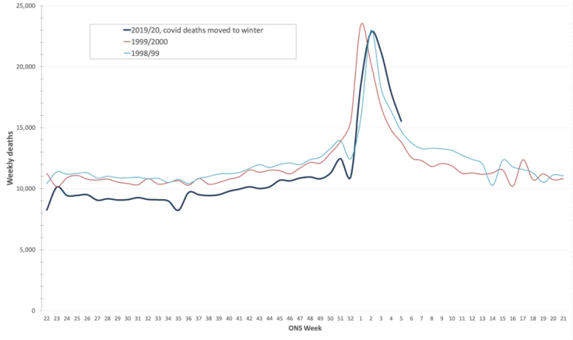](https://swprs.files.wordpress.com/2020/06/uk-flu-comparison.png)Mortality in 2020 compared to the strong flu waves of 1999 and 2000 (adjusted for population growth and 2020 deaths moved to winter). Source: [ONS / OffGuardian](https://off-guardian.org/2020/05/25/were-all-in-the-big-numbers-now/)

**Switzerland**

Medical aspects:

* After about four weeks of relative excess mortality, since the middle of May Switzerland is already in experiencing [below-average mortality](https://swprs.files.wordpress.com/2020/06/schweiz-todesfaelle-2010-2020_woche_22.pdf). The cumulative mortality rate since the beginning of the year is in the range of a **normal flu season** and far below the strong flu season of 2015 (see chart below). Around 50% of deaths occurred in [nursing homes](https://www.nzz.ch/zuerich/coronavirus-zuerich-aendert-nun-das-testregime-in-heimenauch-viele-aeltere-covid-19-infizierte-entwickeln-keine-symptome-zuerich-aendert-nun-das-testregime-in-heimen-ld.1552089) that did not benefit from a lockdown. The median age of deaths is around 84 years, which is slightly *above* the average Swiss life expectancy.
* There were a total of 130 test-positive deaths in the **Canton of Zurich**. More than half of this (78) took place in nursing homes. Again slightly more than half of these deaths (40) took place [in two nursing homes](https://www.republik.ch/2020/05/28/toedlicher-zufall) that had to take Covid19 patients from hospitals and were sometimes unable to adequately isolate them.
* ETH Zurich has [repeatedly rephrased](https://www.luzernerzeitung.ch/schweiz/die-schweiz-haette-die-kurve-auch-mit-weniger-einschraenkungen-gekriegt-war-der-lockdown-uebertrieben-ld.1221111) its study that the decline in the spread of Covid19 began before the **lockdown**, in order not to openly contradict to the Federal Council. But the result [remains the same](https://infekt.ch/2020/04/sind-wir-tatsaechlich-im-blindflug/): the lockdown was medically unnecessary and socially counterproductive. The forecasts of the authorities and universities were based on often completely [unrealistic assumptions](https://www.cash.ch/news/politik/coronavirus-schweizer-wissenschaftler-warnen-vor-knappheit-bei-spitalbetten-1511778).
* Researchers at ETH Lausanne have presented a study warning of the risk of a **“second wave”** that could overwhelm Switzerland. The main author of the study, Professor Jacques Fellay, is also a member of the Federal Council’s Corona Task Force and a supporter of a Corona vaccine. An independent analysis of this study, however, showed that it is based on [completely unrealistic assumptions](https://www.heise.de/tp/features/Fellay-Studie-Zweite-Corona-Welle-4726303.html) and, for example, predicts a constant risk of infection and death for all age groups.
* Medical entrepreneur Stephan Rietiker from **Inside-Corona** comes to [a devastating conclusion](https://www.insidecorona.ch/2020/05/21/coronakrise-professionelles-krisenmanagement-sieht-anders-aus/) with regard to the Corona management of the Federal Council. The Federal Council largely ignored the findings of its own pandemic commission and made grotesquely wrong decisions with serious consequences for the population and the economy. An unsuitable “containment strategy” was pursued in the naive belief that the time until a vaccine could be “bridged”. The planned “contact tracing” will consume tons of money and ultimately “fail miserably”. It is high time to abolish the emergency laws and hold the decision-makers accountable, according to Rietiker.

Media:

* The **Aargauer Zeitung** reported [on the supposedly first child](https://www.aargauerzeitung.ch/aargau/kanton-aargau/erstes-kind-am-coronavirus-gestorben-aargauer-saeugling-zur-behandlung-heimgeflogen-137988950) who “died from the coronavirus”. The infant, flown in from Macedonia in an emergency, actually died of [meningitis](https://www.srf.ch/news/regional/aargau-solothurn/verwirrung-um-todesursache-trauriges-ereignis-aargauer-baby-stirbt-nach-corona-infektion), which is not caused by coronaviruses.
* In May, the **NZZ** once again spread the [false report](https://www.nzz.ch/gesellschaft/wie-corona-das-tessin-an-den-rand-einer-katastrophe-brachte-und-die-willensnation-auf-die-probe-stellte-ld.1556749) that Corona had brought the southern canton of Ticino “to the brink of disaster”. In fact, there were [no serious problems](https://www.blick.ch/news/schweiz/tessin/tessiner-spitaldirektor-widerspricht-dem-bundesamt-fuer-gesundheit-wir-haben-genuegend-intensivbetten-id15808076.html) outside of nursing homes in the canton of Ticino.
* **SRF TV editor-in-chief** Tristan Brenn [defended himself against allegations](https://www.srf.ch/news/schweiz/berichterstattung-zu-corona-srf-chefredaktor-nimmt-stellung-zu-fakenews-vorwuerfen) that SRF was spreading propaganda about Corona. Shortly afterwards, a wheelchair-bound participant in a corona demonstration [pointed out](https://www.youtube.com/watch?v=9BA83YQT7AE) how SRF had used him for propaganda.

Political aspects:

* In Switzerland there have been weekly **demonstrations for fundamental rights** in Bern, Zurich and other cities since April. This led to considerable police violence, see [»Corona repression in Switzerland«](https://swprs.org/corona-repression-in-der-schweiz/). The participants in these demonstrations were mostly defamed by the media as dumb or extremist.
* The Federal Council plans to [convert](https://www.zeitpunkt.ch/petition-gegen-umwandlung-der-notverordnungen-dringliches-bundesrecht-lanciert) the existing **emergency ordinances** [into urgent federal law](https://www.zeitpunkt.ch/petition-gegen-umwandlung-der-notverordnungen-dringliches-bundesrecht-lanciert), whereas an online petition has been launched against this step.
* The Federal Council [adopted](https://www.republik.ch/2020/05/21/haftstrafe-ohne-straftat-lauber-soll-abgesetzt-werden-und-bald-nicht-mehr-alles-in-butter) a legal basis for the **“corona-tracing app”**, which must be approved by Parliament in the summer session. Apple and Google have now equipped their mobile operating systems with an appropriate interface. The use of the app should remain “voluntary” (see above).
* The canton of Zurich and several other cantons have already [set up](https://www.nzz.ch/zuerich/coronavirus-in-zuerich-contact-tracing-ist-gut-angelaufen-ld.1556846) **centers for society-wide contact tracing**, consisting of police and health department employees who are to contact potentially “infected” people and instruct them to be quarantined. The experience of March and April had shown that the center would have to be expanded or outsourced in the future.
* A survey by the University of Applied Sciences ZHAW showed that [40% of Swiss](https://www.zhaw.ch/de/medien/medienmitteilungen/detailansicht-medienmitteilung/event-news/viele-schweizer-fuerchten-ueberwachung-durch-contact-tracing-app/) fear a **stronger monitoring** by “Corona apps”. Still, a majority plan to use the contact tracing app.
* In February 2020, US billionaire and vaccine investor Bill Gates [donated 900,000 US dollars](https://www.christoph-pfluger.ch/2020/05/23/der-groesste-impfstoff-investor-schenkt-der-swissmedic-900000-dollar/) to the Swiss Agency for Therapeutic Products **Swissmedic** for “projects in Africa”.
* Switzerland [will support](https://www.aargauerzeitung.ch/panorama/schweiz-unterstuetzt-impfallianz-gavi-mit-30-millionen-138082583) Bill Gates’ **global vaccine alliance GAVI** with CHF 30 million for the development of a coronavirus vaccine.
* The **Corona-critical doctor from Aargau**, who was brutally arrested in April by a special police unit and temporarily admitted to the psychiatric center, requested an [external administrative investigation](https://www.aargauerzeitung.ch/aargau/kanton-aargau/polizeieinsatz-wegen-wettinger-arzt-regierung-beschliesst-externe-administrativuntersuchung-137913013) into his case, which the government has now initiated. It was previously known that, contrary to what the police had said, the doctor neither threatened relatives nor the authorities nor was he in possession of a loaded weapon.

[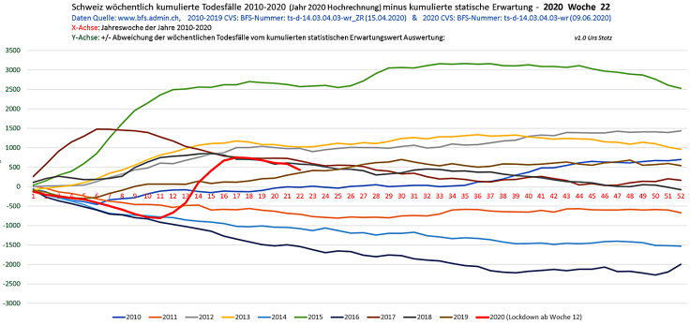](https://swprs.files.wordpress.com/2020/06/schweiz-todesfaelle-2010-2020_woche_22.png)Kumulierte Sterblichkeit im Vergleich zum Erwartungswert (2010-2020, BFS/Stotz)

**Germany and Austria**

* Germany and Austria have **not had any significant excess mortality** since March. In fact, Germany has even seen [a slightly below-average level of mortality](https://swprs.files.wordpress.com/2020/06/breyer-deutschland-untersterblichkeit.pdf) since the beginning of the year if corrected for population growth.
* [Leaked protocols](https://www.falter.at/zeitung/20200512/was-passiert-wenn-es-eng-wird) in Austria, as in Denmark and England, have shown that the **lockdown was politically motivated** and the majority of the health experts spoke out against it, recommending to Chancellor Kurz in March to get away from the message of a “very dangerous virus” because the virus was already widespread and not particularly dangerous for the majority of the population.
* In Germany, [almost a million](https://www.welt.de/wirtschaft/article208557665/Wegen-Corona-In-Deutschland-wurden-908-000-OPs-aufgeschoben.html) **surgeries were** canceled due to the corona lockdown by the end of May. German oncologists [warn of delays](https://deutsch.medscape.com/artikelansicht/4908889) in the diagnosis and treatment of cancer due to the lockdown. Cancer is a “far greater danger than COVID-19,” the medical associations emphasized.
* German **pediatricians** report [massive violence against children](https://www.tagesspiegel.de/politik/knochenbrueche-oder-schuetteltraumata-mediziner-berichten-von-massiver-gewalt-gegen-kinder/25833740.html) due to the lockdown. They see injuries like those after car accidents, including broken bones or shaking trauma. The number of calls to the child protection hotline is rising sharply.
* Berlin medical examiner Professor Michael Tsokos [reported](https://www.bz-berlin.de/berlin/michael-tsokos-berlins-bekanntester-gerichtsmediziner-spricht-von-corona-suiziden-durch-panikmache) **“corona suicides”** from people who fear or think they may be infected. Professor Tsokos criticized the scaremongering and spread of “horror scenarios” by the media and some virologists. He fears that the “infectious pandemic” will now be followed by a “psycho-social pandemic”. In fact, suicides and suicide attempts in Berlin already [“increased dramatically”](https://www.tichyseinblick.de/daili-es-sentials/suizide-in-berlin-steigen-im-ersten-quartal-drastisch/) in the first quarter.
* Economic experts in Germany expect [around 10,000 additional](https://www.focus.de/finanzen/news/konjunktur/insgesamt-fast-30-000-insolvenzen-in-deutschland-experten-geben-erste-schaetzung-ab-corona-treibt-10-000-deutsche-firmen-in-die-pleite_id_12003269.html) **bankruptcies by** 2021 due to the political corona measures.
* Since April some of the largest **fundamental rights demonstrations in** Europe have taken place in German cities with up to 25,000 participants. However, there was sometimes serious police violence, for example when arresting vegan celebrity chef [Attila Hildmann](https://www.youtube.com/watch?v=20HIEEQtyZ8) or 68-year-old former GDR civil rights activist [Angelika Barbe](https://www.youtube.com/watch?v=fCbgVFRCnTc). There were also [arson attacks](https://www.swr.de/swraktuell/baden-wuerttemberg/spreng-anschlag-100.html) and, in some cases, life-threatening [attacks](https://www.swr.de/swraktuell/baden-wuerttemberg/stuttgart/corona-demo-in-stuttgart-ermittlungen-wegen-versuchter-toetung-100.html) on demonstrators and independent [media people](https://kenfm.de/anschlagsversuch-auf-ken-jebsen-tagesdosis-9-6-2020/) by mostly black-hooded groups that apparently are not afraid of state persecution.
* **Werner Winterstein**, the grandson of an Austrian-Jewish Minister of Justice murdered by the Nazis, took part in a fundamental rights demonstration in Vienna [and declared](https://vimeo.com/418039066) that he was “shaken by the silent seizure of power by elements that speak of ‘new normality’ on the margins of the democratic model. ” The corona-related division of citizens into different categories and the creation of a new “snitch culture” are dangerous developments. He observed a lack of civil courage and submission to the authorities. The planned Corona apps are a move “towards a total surveillance state” and should be rejected.

[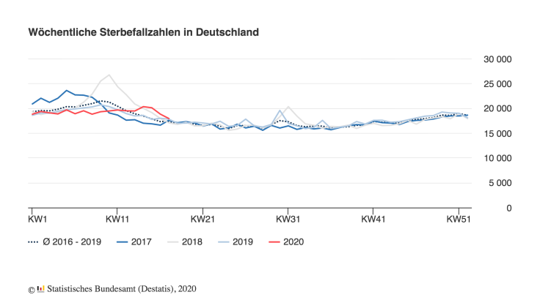](https://swprs.files.wordpress.com/2020/06/sterbefallzahlen-de-25-05.png)Weekly mortality in Germany, 2017 to 2020 (Destatis/RKI)

**South America and Africa**

After the spread of corona in Europe and the United States subsided, many media focused on the situation in South America, especially in **Brazil**. However, the fact is that with about 40,000 deaths to date and the curve already flattening, Brazil’s 210 million inhabitants are [better off](https://www.statista.com/statistics/1104709/coronavirus-deaths-worldwide-per-million-inhabitants/) than many European countries including Switzerland.

In other Latin American countries such as **Ecuador**, in addition to the coronavirus, [dengue fever also](https://www.bbc.com/mundo/noticias-america-latina-52383340) spreads with similar symptoms, which has lead to a double burden on the health system. Nevertheless, in **Peru** it was found that 80% of confirmed corona cases [remain asymptomatic](https://exitosanoticias.pe/v1/covid-19-minsa-el-80-de-casos-confirmados-en-el-peru-son-asintomaticos/).

Some media reported crematoriums running allegedly “around the clock” in **Mexico City**. A Youtuber living in Mexico [then visited](https://www.youtube.com/watch?v=_vQhwEZpDPE) the city and the hospitals, funeral homes and crematoriums there, all of which had very little activity.

In general, there has been a [much lower corona mortality rate](https://www.msn.com/en-gb/news/world/coronavirus-why-africa-seems-to-have-few-cases/ar-BB10MNJd) in countries in South America and Africa than in Europe and the USA, which may be due to the younger population or climatic factors. On the other hand, the World Bank expects up to [60 million victims of poverty](https://www.deccanherald.com/business/economy-business/world-bank-says-covid-19-to-push-60-million-into-poverty-announces-usd-160-billion-assistance-to-100-countries-839661.html) due to global political corona measures.

**C. Global health funding by Bill Gates**

US multi-billionaire and Microsoft founder Bill Gates is the most important private sponsor of the WHO and the vaccine industry and is therefore currently in the spotlight. In the following illustrations his pharmaceutical and media network is graphically represented.

**See also**: Politico (2017): [Meet the world’s most powerful doctor: Bill Gates](https://www.politico.eu/article/bill-gates-who-most-powerful-doctor/)

[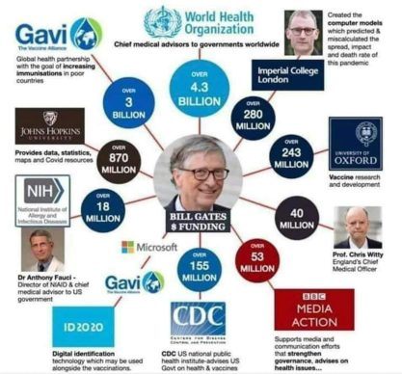](https://swprs.files.wordpress.com/2020/05/gates-funding-e1590256423190.jpg)

[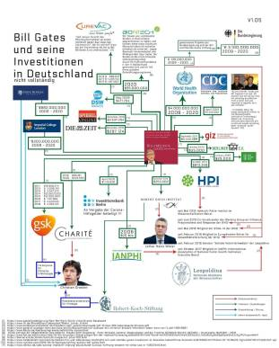](https://swprs.files.wordpress.com/2020/05/gates-foundation.jpg)

Global health funding by Bill Gates in the US/UK and Germany

(Last updated: June 15, 2020)

**May 2020**

**Expert interviews**

* Stanford professor **John Ioannidis** explains [in an interview with CNN](https://twitter.com/cnn/status/1256579248342564865) that Covid19 is a “widespread and mild disease” comparable to influenza (flu) for the general population, while patients in nursing homes and hospitals should receive extra protection.
* Stanford professor **Scott Atlas** explains [in an interview with CNN](https://www.facebook.com/cnn/posts/10160799274796509) that “the idea of having to stop Covid19 has created a catastrophic health care situation”. Professor Atlas says that the disease is “generally mild” and that irrational fears had been created. He adds that there is “absolutely no reason” for extensive testing in the general population, which is only necessary in hospitals and nursing homes. Professor Atlas wrote an article at the end of April entitled [“The data are in – Stop the panic and end total isolation”](https://thehill.com/opinion/healthcare/494034-the-data-are-in-stop-the-panic-and-end-the-total-isolation) that received over 15,000 comments.
* Epidemiologist **Dr Knut Wittkowski** [explains in a new interview](https://www.thepressandthepublic.com/post/perspectives-on-the-pandemic-v) that the danger of Covid19 is comparable to an influenza and that the peak was already passed in most countries before the lockdown. The lockdown of entire societies was a “catastrophic decision” without benefits but causing enormous damage. The most important measure is the protection of nursing homes. According to Dr. Wittkowski, Bill Gates’ statements on Covid19 are “absurd” and “have nothing to do with reality”. Dr. Wittkowski considers a vaccination against Covid19 “not necessary” and the influential Covid19 model of British epidemiologist Neil Ferguson a “complete failure”. (**Note**: The video was removed by Youtube).
* German virologist **Hendrik Streeck** [explains the final results](https://www.youtube.com/watch?v=vrL9QKGQrWk) of his pioneering antibody study. Professor Streeck found a Covid19 lethality of 0.36%, but explains that this is an upper limit and the lethality is probably in the range of 0.24 to 0.26% or even below. The average age of test-positive deceased was approximately 81 years. Professor Streeck argues that “waiting for a vaccine” is not a good strategy because both the feasibility and effectiveness of a vaccine are uncertain.
* Biology professor and Nobel Prize winner **Michael Levitt**, who has been analyzing the spread of Covid19 since February, describes the general lockdown as [a „huge mistake“](https://www.youtube.com/watch?v=bl-sZdfLcEk) and calls for more targeted measures, especially to protect risk groups.
* The emeritus microbiology professor **Sucharit Bhakdi** explains [in a new interview](https://www.servustv.com/videos/aa-23zjmvcz51w12/) that politics and the media have been conducting an “intolerable fear-mongering” and an “irres­pon­sible disinformation campaign”. According to professor Bhakdi, face masks for the general population are not needed and may in fact be harmful “germ catchers”. The current crisis was brought about by the politicians themselves and has little to do with the virus, he argues, while a vaccine against coronavirus is “unnecessary and dangerous”, as was already the case with swine flu. The WHO has “never taken responsibility for its many wrong decisions over the years”, professor Bhakdi adds. (**Note**: The video was temporarily deleted by YouTube).
* The Swiss chief physician for infectiology, **Dr. Pietro Vernazza**, explains [in a new interview](https://www.saldo.ch/artikel/artikeldetail/fuer-die-allermeisten-menschen-verlaeuft-die-erkrankung-mild/) that the Covid19 disease is “mild for the vast majority of people” and the “counting of infected people and the call for more tests” aren’t helpful. In addition, most of the people listed in the corona statistics did not die solely from Covid-19. According to Dr. Vernazza, there is no evidence for the benefit of face masks in people who do not show symptoms themselves ([archive](https://swprs.files.wordpress.com/2020/05/saldo-interview-pietro-vernazza-14-04-2020.pdf)).

**Medical studies**

* A [new overview of existing PCR and antibody studies](https://swprs.org/studies-on-covid-19-lethality/) shows that the median value of Covid19 lethality (IFR) is about 0.2% and thus in the range of a strong influenza.
* A new [antibody study with Danish blood donors](https://www.medrxiv.org/content/10.1101/2020.04.24.20075291v1) showed a very low Covid19 lethality (IFR) of 0.08% for persons under 70 years of age.
* A [new antibody study](https://www.medrxiv.org/content/10.1101/2020.04.26.20079244v1) from Iran, one of the earliest and most affected countries by Covid19, also showed a very low lethality of 0.08% to 0.12%.
* A new [antibody study from Japan](https://www.medrxiv.org/content/10.1101/2020.04.26.20079822v1) comes to the conclusion that about 400 to 800 times more people there had contact with the new coronavirus than previously thought, but showed no or hardly any symptoms. Japan had done rather few tests so far.
* A [new study from Germany](https://www.medrxiv.org/content/10.1101/2020.04.17.20061440v1), with the participation of leading virologist Christian Drosten, shows that about one third of the population already has some **cellular immunity** to the Covid19 corona virus, presumably through contact with earlier corona viruses (cold viruses). This cellular immunity by so-called T-cells is significantly higher than PCR and antibody tests suggested and may partly explain why many people develop no symptoms with the new coronavirus.
* In a prison in the US state of Tennessee, only two out of 1349 test-positive people [showed any symptoms](https://www.tennessean.com/story/news/politics/2020/05/01/tennessee-testing-all-inmates-prison-staff-after-multiple-outbreaks/3067388001/) at all.
* On the French **aircraft carrier** Charles de Gaulle, [none](https://en.wikipedia.org/wiki/COVID-19_pandemic_on_Charles_de_Gaulle) of 1046 test-positive sailors have died so far. On the US aircraft carrier Theodore Roosevelt, [one](https://en.wikipedia.org/wiki/COVID-19_pandemic_on_USS_Theodore_Roosevelt) of 969 test-positive sailors has died so far (preconditions and exact cause of death are not known). This yields a lethality rate of 0 to 0.1% for this population group.
* Numerous media reported about alleged **“re-infections”** of already recovered persons in South Korea. However, researchers have now [come to the conclusion](https://www.independent.co.uk/news/world/asia/coronavirus-south-korea-patients-infected-twice-test-a9491986.html) that all of the 290 suspected cases were *false-positive test results* caused by “non-infectious virus fragments”. The result again highlights the [well-known unreliability](https://www.ncbi.nlm.nih.gov/pubmed/32219885) of PCR virus tests.

**Other medical updates**

* Numerous media reported that in connection with Covid19, more and more children would fall ill with so-called **Kawasaki disease** (a vascular inflammation). However, the UK’s Kawasaki Disease Foundation issued a [press release stating](https://www.societi.org.uk/kawasaki-disease-and-covid-19/) that *fewer, not more,* Kawasaki cases are currently being reported than usual and that of the few cases reported, only about half had tested positive for corona virus.
* In an [open letter to the French Ministry of Health](https://covidinfos.net/covid19/la-lettre-dun-praticien-hospitalier-adressee-au-ministere-de-la-sante-denonce-une-arnaque-sanitaire/604/), a **French doctor** speaks of Covid19 as “the biggest health scam of the 21st century”. The danger of the virus for the general population is in the range of influenza and the consequences of the lockdown are more dangerous than the virus itself, the French doctor argues.
* In **France**, it became known during a subsequent investigation that the first Covid19-positive patient had already been treated [at the end of December 2019](https://www.reuters.com/article/us-health-coronavirus-france-retests/frances-early-covid-19-case-may-hold-clues-to-pandemics-start-idUSKBN22H15R), one month earlier than previously assumed. The man was being treated for what appeared to be flu-related pneumonia. This case shows that the new corona virus either arrived in Europe earlier than assumed, or that it is not as new as assumed, or that the test result was a false-positive. In addition, it is not clear whether the man, who has long since recovered, was actually suffering from flu or corona virus or both.
* The Executive Director of the WHO recently praised **Sweden** as [a successful model](https://nypost.com/2020/04/29/who-lauds-sweden-as-model-for-resisting-coronavirus-lockdown/) for handling Covid19. Sweden had implemented its health policy successfully and “in partnership with the population”, he said. Previously, Sweden had been heavily criticized for weeks by foreign media and politicians for its relaxed approach to Covid19.
* **Belarus**, which took the least action against Covid19 of all European countries and did not even cancel major events like soccer matches, is counting only 103 test-positive or suspected [Covid19 deaths](https://en.wikipedia.org/wiki/COVID-19_pandemic_in_Belarus) after more than two months. The Belarusian long-term president Lukashenko called Corona [a “psychosis”](https://www.baltictimes.com/lukashenko__coronavirus_is_psychosis/). Critics argue he is not disclosing the real number of deaths.
* An [extensive literature review](https://covidinfos.net/wp-content/uploads/2020/05/MasksDon-twork-4.pdf) by a Canadian researcher found that **face masks** do not provide measurable protection against colds and influenza.
* A Swiss chief psychiatrist expects a sharp increase in **psychological problems** and [more than 10,000 additional suicides](https://www.aargauerzeitung.ch/aargau/kanton-aargau/aargauer-psychiatrie-chefarzt-kawohl-warnt-arbeitslosigkeit-erhoeht-das-suizidrisiko-137742663) worldwide due to the global lockdown and unemployment.
* The so-called **reproduction number**, which indicates the proliferation of Covid, is increasingly becoming [a political issue](https://www.tagesschau.de/faktenfinder/corona-reproduktionszahl-101.html). However, this does not change the facts: the peak of the spread was already reached in most countries before the lockdown and the reproduction ratio fell to or below the stable value of one due to simple everyday and hygiene measures. The lockdown was therefore epidemiologically [unnecessary](https://infekt.ch/2020/04/sind-wir-tatsaechlich-im-blindflug/).
* The **clinical picture and risk groups** of Covid19 corona viruses are probably related to the use of the so-called [ACE2 cell receptor](https://www.news-medical.net/news/20200420/ACE2-TMPRSS2-profiling-indicates-tissue-vulnerability-to-SARS-CoV-2-infection.aspx), which is found in the bronchi and lungs, but also in blood vessels, the intestines and kidneys. However, other coronaviruses such as the [common cold virus NL63](https://www.ncbi.nlm.nih.gov/pmc/articles/PMC4369385/), also use the ACE2 cell receptor. Some researchers therefore [expect that](https://www.ncbi.nlm.nih.gov/pmc/articles/PMC7074995/) the Covid19 coronavirus, too, will be seen as a typical cold virus in the medium term.
* The exact **origin of the new corona virus** is still unclear. The easiest explanation remains natural transmission or mutation, which happens quite often. It is true, however, that the virological laboratory in Wuhan, as part of a [research programme co-financed by the US](https://www.newsweek.com/dr-fauci-backed-controversial-wuhan-lab-millions-us-dollars-risky-coronavirus-research-1500741), studied corona viruses from bats and also examined their transmissibility to other mammals, something that has been criticised for years by some researchers as too risky. The director of the laboratory, however, explained that the new virus [did not correspond](https://www.scientificamerican.com/article/how-chinas-bat-woman-hunted-down-viruses-from-sars-to-the-new-coronavirus1/) to the corona viruses investigated in the laboratory. At any rate, earlier rumours about “bioweapons” or “HIV sequences” turned out to be [disinformation](https://onlinelibrary.wiley.com/doi/full/10.1111/eci.13222) given the relative harmlessness of the corona virus.

**Nursing Homes**

Nursing homes play an [absolutely key role](https://ltccovid.org/2020/04/12/mortality-associated-with-covid-19-outbreaks-in-care-homes-early-international-evidence/) in the current corona situation. In most Western countries, 30% to 70% of all deaths “related to Covid” occurred in nursing homes (in some regions even up to 90%). It is also known from northern Italy that the crisis there began with a [panic-induced collapse of nursing care for the elderly](https://swprs.org/covid-19-a-report-from-italy/).

Nursing homes require targeted protection and do not benefit from a general lockdown of society. If one looks only at the deaths in the general population, in most countries these are in the range of a normal or even mild wave of influenza.

Moreover, in many cases it is not clear what people in nursing homes really died of, i.e. whether it was Covid19 or stress, fear and loneliness. From Belgium, for example, it is known that [about 94%](https://web.archive.org/web/20200424212535/https:/covid-19.sciensano.be/sites/default/files/Covid19/Meest%20recente%20update.pdf) of all deaths in nursing homes are untested “presumed cases”.

A [new analysis of French statistics](https://covidinfos.net/covid19/deces-dus-au-covid-19-le-nombre-officiel-de-morts-en-france-est-il-surestime/502/) moreover shows the following: as soon as there is a “suspected case” in a nursing home (e.g. due to coughing), all deaths are considered “suspected Covid19 deaths”, and as soon as there is a “confirmed case” in a nursing home (even if symptomless), all deaths are considered “confirmed Covid19 deaths”.

A report from Germany vividly describes the [extreme conditions](https://www.rnd.de/gesundheit/corona-ist-mir-egal-warum-helga-witt-kronshage-86-lieber-sterben-will-als-eingesperrt-zu-sein-3MEBDIOBEFA6BDULC4N5WGZJG4.html) under which hundreds of thousands of patients in care and nursing homes have had to live in recent weeks, often against their will. Many of the patients were barely allowed to leave their rooms, were no longer allowed to go out into the fresh air or receive visits from their relatives.

In several nursing homes, the error-prone PCR virus test moreover led to [serious false alarms](https://www.wjhl.com/local-coronavirus-coverage/agape-nursing-home-says-residents-who-tested-positive-for-covid-19-were-false-positives/) and panic. In one Canadian nursing home, employees fled in fear of the corona virus, resulting in the [tragic death of 31 patients](https://www.nytimes.com/2020/04/16/world/canada/montreal-nursing-homes-coronavirus.html) due to lack of care.

The former New York Times journalist and Corona critic Alex Berenson [writes on Twitter](https://twitter.com/AlexBerenson/status/1257496834043531267): “Let’s be clear: the fact the nursing home deaths are not front and center every day in elite media coverage of COVID tells you everything you need to know about the media’s priority – which is instilling panic (and punishing Trump), not driving good health policy.”

**Full analysis**: [Mortality associated with COVID-19 outbreaks in care homes: early international evidence](https://ltccovid.org/2020/04/12/mortality-associated-with-covid-19-outbreaks-in-care-homes-early-international-evidence/) (LTC Covid, May 2020)

[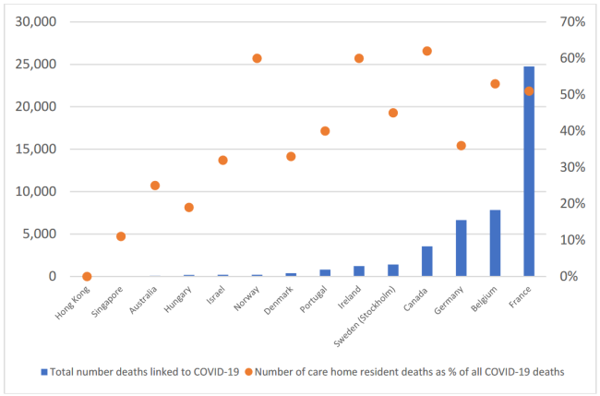](https://swprs.files.wordpress.com/2020/05/care-homes-covid.png)Deaths in nursing homes, absolute and percentage figures (LTC Covid)

**Great Britain**

* Cumulative all-cause mortality in the UK remains [in the range of the five strongest flu waves](http://inproportion2.talkigy.com/) in the last 25 years. The peak in daily hospital deaths was already reached on April 8 (s. chart below).
* New [statistical data show](https://www.telegraph.co.uk/politics/2020/05/01/evidence-rising-britains-lockdown-could-deadly-mistake/) that in mid-April, out of about 12,000 additional deaths, about 9,000 were “related to Covid” (including “suspected cases”), but about 3,000 were “not related to Covid”. Moreover, of the total of about 7300 deaths in nursing homes, only about 2000 were “related to Covid”. In both the “Covid19 deaths” and the non-covid19 deaths, it is [often unclear](https://www.hsj.co.uk/commissioning/thousands-of-extra-deaths-outside-hospital-not-attributed-to-covid-19/7027459.article) what these people actually died of. The Association of British Pathologists has therefore called for a [“systematic review of the true causes of death”](https://www.hsj.co.uk/coronavirus/systematic-reviews-to-discover-true-cause-of-outbreak-deaths/7027491.article).
* The temporary “Nightingale” hospitals in the UK have so far [remained largely empty](https://www.telegraph.co.uk/news/0/do-many-nhs-nightingale-hospitals-remain-empty/). A similar situation was already seen in China, the US and many other countries.
* At the end of April it became known that the lockdown was apparently not, as officially stated, recommended by a scientific commission alone, but that a high government advisor [had “pushed” the scientists](https://www.bloomberg.com/news/articles/2020-04-28/top-aide-to-u-k-s-johnson-pushed-scientists-to-back-lockdown) to support the lockdown.
* Peter Hitchens: [We’re destroying the nation’s wealth – and the health of millions](https://hitchensblog.mailonsunday.co.uk/2020/05/peter-hitchens-were-destroying-the-nations-wealth-and-the-health-of-millions.html). “If you don’t defend your most basic freedom, the one to go lawfully where you wish when you wish, then you will lose it for ever. And that is not all you will lose. Look at the censorship of the internet, spreading like a great dark blot, the death of Parliament, the conversion of the police into a state militia.”

[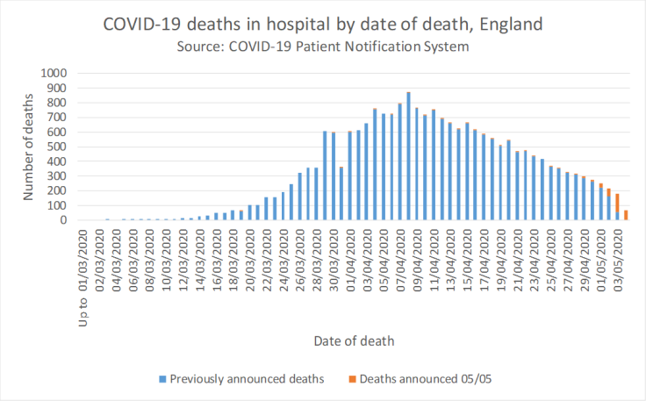](https://swprs.files.wordpress.com/2020/05/england-deaths.png)England: Test-positive deaths in hosptials ([NHS](https://www.england.nhs.uk/statistics/statistical-work-areas/covid-19-daily-deaths/))

**United States**

* The [latest report from the US CDC](https://www.cdc.gov/coronavirus/2019-ncov/covid-data/covidview/index.html) shows that the Covid19 hospitalization rate among the over-65s is in the range of strong flu waves. It is slightly higher among 18 to 64-year-olds and significantly lower among those under 18.
* **Video**: A nurse from New York City [stated in a dramatic video](https://www.dailymail.co.uk/news/article-8262351/Nurse-New-York-claims-city-killing-COVID-19-patients-putting-ventilators.html) that New York is “killing” Covid19 patients by putting them on invasive ventilators and destroying their lungs. The use of the invasive ventilators (instead of oxygen masks) is done “for fear of spreading the virus”. It is “a horror movie”, “not because of the disease, but because of the way it is dealt with”, the nurse explained. Experts [have been warning](https://off-guardian.org/2020/05/06/covid19-are-ventilators-killing-people/) since March against intubation of Covid19 patients.
* Dr. Daniel Murphy, the head of emergency medicine at a heavily affected hospital in New York City, [recommends a quick end](https://nypost.com/2020/04/27/ive-worked-the-coronavirus-front-line-and-i-say-its-time-to-start-opening-up/) to the lockdown. According to Dr Murphy, the Covid19 wave had already reached its peak on April 7th. Covid19 is a serious matter, but the fear of it is exaggerated, as the vast majority of the population gets at most mildly ill. His biggest concern now is the sharp decline in the care of emergency patients and children due to the lockdown and the widespread fear in the population.
* **Video**: The conservative Project Veritas whistleblower platform [spoke with New York funeral home directors](https://www.youtube.com/watch?v=g5f_6ltv7oI) who stated that currently Covid is written “on all death certificates” (of suspected cases), whether there was a test or not. Many people are currently dying at home, and often the exact cause of death is no longer checked. The Covid19 statistics are inflated for political or financial reasons, the directors stated.
* The director of the Illinois Department of Health [confirmed that](https://week.com/2020/04/20/idph-director-explains-how-covid-deaths-are-classified/) even terminally ill people who clearly die of another cause but who test positive for Covid19 virus before or after death are recorded as Covid19 deaths.
* Due to the lockdown, 30 million people in the US have already [applied for unemployment benefits](https://edition.cnn.com/2020/04/30/economy/unemployment-benefits-coronavirus/index.html) by the end of April – that is significantly more than the International Labour Office ILO originally assumed for the entire world.
* Tesla boss Elon Musk called the California curfews [“fascist”](https://www.theguardian.com/technology/2020/apr/29/tesla-quarterly-earnings-coronavirus-shares). The “forced imprisonment” of people in their homes violates all their constitutional rights, Musk explained in a telephone conference.
* **Video**: A Wisconsin mother was [confronted by police](https://twitter.com/AlexBerenson/status/1256219418343981056) at her home because her children played illegally with neighbor children.
* **Video**: In late April, some photographers were caught in a [partial staging of a protest](https://twitter.com/talialikeitis/status/1253126254942773248) by care workers against anti-lockdown demonstrators. ([Read more](https://www.buzzfeednews.com/article/tasneemnashrulla/photos-denver-nurses-block-anti-lockdown-protest)).

**Switzerland**

* Cumulative deaths since the beginning of the year in Switzerland remain within the range [of a normal flu epidemic](https://swprs.files.wordpress.com/2020/05/schweiz-todesfaelle-2010-2020_woche_17.pdf) and far below the strong flu epidemic of 2015 (see graph below). Around [50% of deaths](https://www.bluewin.ch/de/news/schweiz/sp-chef-levrat-will-die-reichen-schropfen-383977.html) occurred in care and nursing homes.
* The Swiss government plans to transform the current corona emergency decrees into a [permanent urgent federal law](https://www.admin.ch/gov/de/start/dokumentation/medienmitteilungen.msg-id-78929.html). Most Swiss media have not reported on this far-reaching announcement, or have done so only marginally.
* The Swiss Armed Forces began [testing an app for contact tracing](https://uncut-news.ch/wp-content/uploads/2020/05/Schweizer-Soldaten-k%C3%A4mpfen-bewaffnet-mit-Bluetooth-App-gegen-COVID-19.pdf) that is to be introduced on 11 May in collaboration with Google and Apple. Meanwhile, a Swiss “data protection office” [declared](https://www.nzz.ch/zuerich/coronavirus-in-zuerich-tracing-app-braucht-keine-freiwilligkeit-ld.1553964): “If the contact tracing app is suitable and necessary, it does not need to be voluntary”.
* Various vigils [were held on the Swiss Bundesplatz in Berne](https://www.zeitpunkt.ch/index.php/mahnwache-fuer-grundrechte-400-menschen-auf-dem-bundesplatz-wie-aus-dem-nichts) with around 400 participants who spoke out against restrictions on constitutional rights. The rallies were cleared by the police.
* In the context of Covid19, it was not the long-established [Swiss Pandemic Commission](https://www.srf.ch/news/schweiz/bag-verzichtete-auf-beratung-was-macht-die-pandemie-kommission-in-der-krise) that was used, but a newly founded [“Covid-19 Task Force”](https://ncs-tf.ch/de/organisation), some of whose members have conflicts of interest in the pharmaceutical sector.
* **Video**: [“Does the Swiss government belong in prison?”](https://www.youtube.com/watch?v=RyZGkdeQ6CY) Swiss journalist Reto Brennwald interviewed the entrepreneur [Daniel Stricker](https://www.youtube.com/user/timturpis/videos), who temporarily fled Switzerland to Sweden in mid-March and strongly criticizes the corona policy of the Swiss government.
* A Swiss nurse has written a [highly shared article](https://www.facebook.com/simone.christinat/posts/10221314943115981) on the current situation. She explains that Swiss hospitals have remained largely empty and in some cases had to furlough staff. She also says it is very unusual to transfer people over 80 years of age to intensive care units because of flu or pneumonia, where they then have to die alone instead of with their families. If this were done, the intensive care units would be overloaded almost every winter. The nurse criticises that most of the media have not sufficiently addressed the recent scientific findings on the rather low overall risk of Covid19.

[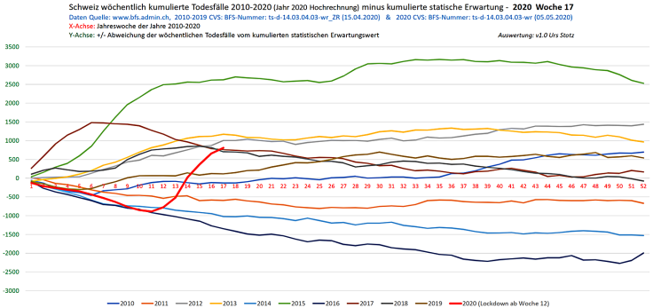](https://swprs.files.wordpress.com/2020/05/schweiz-todesfaelle-2010-2020_woche_17-1.png)Cumulative deaths compared to expected deaths, 2010 to 2020 (KW17, BFS/Stotz)

**Germany and Austria**

* In Germany and Austria, similar to Denmark, Finland, Greece, Hungary, Ireland, Luxembourg, Malta, Norway and Portugal, [no excess mortality exists](https://www.euromomo.eu/graphs-and-maps/) to date.
* According to a leaked protocol of the Austrian Corona Task Force, Chancellor Kurz is said to have demanded in March that the population should be [“more afraid”](https://www.derstandard.de/story/2000117131591/sitzungsprotokoll-der-taskforce-corona-ueber-zu-wenig-angst-in-der) of infection or death of parents or grandparents. A strategy paper of the German Federal Ministry of the Interior had already [become known earlier](https://fragdenstaat.de/dokumente/4123-wie-wir-covid-19-unter-kontrolle-bekommen/), which also called for a psychological fear campaign that was indeed implemented by politicians and the media. In retrospect, the question arises as to how many people died as a result of this largely unfounded fear.
* An open letter with already about 5000 signatures from people over 64 years of age [demands](https://www.change.org/p/bundeskanzlerin-corona-sch%C3%BCtzen-sie-%C3%A4ltere-nicht-um-diesen-preis-selbstbestimmt-altern-und-sterben): “Corona: Don’t protect us older people at this price! Let us decide for ourselves!” For the protection of risk groups, the basic rights of the entire society should not be overridden, the authors argue.
* In Austria (and possibly also in other countries) kissing among people in love but not living together is [still forbidden](https://www.unsertirol24.com/2020/04/29/oeffentliches-kuessen-wird-unter-strafe-gestellt/). This applies both in public and in one’s own flat, explained the Austrian Minister of Health.
* A German lawyer is currently suing in several courts against the government anti-corona measures, as they are [“blatantly unconstitutional”](https://www.rubikon.news/artikel/eklatant-verfassungswidrig-2).
* **Videos**: In Germany there have recently been several cases of serious police overreach. A young woman was [brutally arrested](https://www.youtube.com/watch?v=TZrKv4-jkK8) by several police officers while shopping, as she had apparently “got 20cm too close” to a policewoman. Another woman [was instructed by the police](https://twitter.com/ChristianFritze/status/1256609660318224385) at a rally not to hold the German constitution in front of her chest, as this was an “illegal political message”. The organizer of a peaceful rally in Berlin was also arrested in a [rather brutal fashion](https://www.youtube.com/watch?v=NbV2OH3uYxI). Even older women were arrested in a [disproportionate manner](https://www.youtube.com/watch?v=Bn11jXTjh_Y). (**Caution**: disturbing footage of police violence).

**Other updates**

* The CEO of Youtube announced in an interview at the end of April that video contributions on coronavirus that contradict the guidelines of the WHO or national health authorities [will be removed](https://www.businessinsider.com/youtube-will-ban-anything-against-who-guidance-2020-4). For example, the video of the two skeptic Californian emergency doctors, which had over five million views, [was deleted](https://www.turnto23.com/news/coronavirus/video-interview-with-dr-dan-erickson-and-dr-artin-massihi-taken-down-from-youtube). Likewise, the interview with Professor Sucharit Bhakdi linked above was at least temporarily removed by Youtube.
* In the US magazine The Atlantic, two law professors wrote [an article entitled](https://www.theatlantic.com/ideas/archive/2020/04/what-covid-revealed-about-internet/610549/): “Internet Speech Will Never Go Back to Normal. In the debate over freedom versus control of the global network, China was largely correct, and the U.S. was wrong.”
* Mathias Döpfner, CEO of Axel Springer and one of the most influential media managers in Germany, calls for a [“decoupling from China”](https://www.german-foreign-policy.com/news/detail/8263/) and a strengthening of the transatlantic alliance with the USA in the wake of the Corona crisis.
* Washington Post: [“The last time the government sought a ‘warp speed’ vaccine, it was a fiasco”](https://www.washingtonpost.com/history/2020/05/01/vaccine-swine-flu-coronavirus/). The 1976 swine flu express vaccination led to paralysis and deaths.
* Looking back: [Woodstock Occurred in the Middle of a Pandemic](https://www.aier.org/article/woodstock-occurred-in-the-middle-of-a-pandemic/). On the rather relaxed handling of the global flu pandemic of 1968 ([read more](https://www.britannica.com/event/Hong-Kong-flu-of-1968)).

**Covid-19 and the media**

A lot of people are shocked by the dubious and often fear-mongering Covid19 reporting of many media outlets. Obviously, this is not “ordinary reporting”, but classical and massive propaganda, as it is typically employed in connection with [wars of aggression](https://swprs.org/propaganda-in-the-war-on-yugoslavia/) or alleged [terrorism](https://www.motherjones.com/politics/2013/01/terror-factory-fbi-trevor-aaronson-book/).

SPR has depicted the media networks responsible for the dissemination of such propaganda in earlier infographics [for the USA](https://swprs.org/the-american-empire-and-its-media/), for [Germany](https://swprs.org/netzwerk-medien-deutschland/) and for [Switzerland](https://swprs.org/netzwerk-medien-schweiz/). Even the supposedly “open” Internet lexicon Wikipedia is [an integral part](https://swprs.org/wikipedia-disinformation-operation/) of this geopolitical media structure.

The political stance and relationship to power of different media outlets have been analyzed and compared as part of the [SPR Media Navigator](https://swprs.org/media-navigator/). The Media Navigator may also be helpful in evaluating the current Covid19 reporting by different media outlets.

If, for example, pictures of soldiers in protective suits disinfecting entire streets are seen on television, this does not prove the danger of the corona virus, but rather – as Professor Giesecke [put it benevolently](https://www.addendum.org/coronavirus/interview-johan-giesecke/) – proves useless “political activism”. Or as others would put it: propaganda.

**Covid-19 and mass surveillance**

By far the most significant and, from a civil society perspective, the most dangerous development in response to the coronavirus is the apparent political attempt to massively expand mass surveillance and control of society. In this context, NSA whistleblower Edward Snowden warned of the emergence of an [“architecture of oppression”](https://www.vice.com/en_us/article/bvge5q/snowden-warns-governments-are-using-coronavirus-to-build-the-architecture-of-oppression).

The flu-like coronavirus may serve as a rationale or pretext for the introduction of [strategic measures](https://norberthaering.de/die-regenten-der-welt/id2020-ktdi-apple-google/) to expand monitoring and control of an increasingly uneasy society. The most important instruments currently under discussion by several governments include:

1. The introduction of applications for “tracing” contacts across society
2. The establishment of units to enforce the tracing and isolation of citizens
3. The introduction of digital biometric ID cards to control and regulate participation in social and professional activities.
4. The extended control of travel and payment transactions (including the abolition of cash).
5. The creation of a legal basis for access to and intervention in citizens’ biological systems by governments or corporations (based on so-called “compulsory vaccinations”).

In the US, former President Bill Clinton discussed the introduction of a national network of “contact tracers” [with governors of various states](https://www.youtube.com/watch?v=-Ug9XHT9JQQ) in April. The governor of New York, Andrew Cuomo, then announced that together with billionaire and former New York City mayor Michael Bloomberg, he would [create a “contact tracing army”](https://www.cbsnews.com/news/contact-tracing-new-york-cuomo-plan/) with up to 17,000 contact tracers for New York.

Meanwhile, in the UK and many other countries, governments are calling for the introduction of [biometric “immunity passports”](https://www.msn.com/en-us/money/news/the-uk-just-published-blueprints-for-covid-19-immunity-passports-a-controversial-potential-route-out-of-lockdown/ar-BB13qr8L) and presenting them as the allegedly “only way out” of the primarily politically motivated lockdown. The British Tony Blair Institute called for the [“expansion of technological surveillance”](https://www.theguardian.com/world/2020/apr/24/surveillance-a-price-worth-paying-to-beat-coronavirus-says-blair-thinktank) to “combat the corona virus”.

In the US, the Silicon Valley data analysis company Palantir is to play a key role in [setting up the data platform](https://www.msn.com/en-us/news/us/team-trump-turns-to-peter-thiel-s-palantir-to-track-virus/ar-BB130qfE) for monitoring the (already declining) spread of the corona virus. Palantir is known for its IT projects with intelligence agencies and the military and was founded by US billionaire and Trump supporter Peter Thiel.

In Israel, contact monitoring of the civilian population is [carried out by](https://www.techdirt.com/articles/20200402/14261944226/controversial-spyware-vendor-nso-group-is-helping-israeli-government-spy-own-citizens.shtml) the domestic intelligence service Shin Bet, using programs from the notorious NSO Group, known for its spy software used to monitor civil and human rights activists around the world.

Countries like Russia and China also want to [massively expand](https://www.npr.org/sections/coronavirus-live-updates/2020/04/01/825329399/moscow-launches-new-surveillance-app-to-track-residents-in-coronavirus-lockdown) the surveillance of the population in the wake of the alleged “corona crisis”, but will most likely do so independently of the US.

The idea that a pandemic can be used to expand control of the population is not new: as early as 2010, the American Rockefeller Foundation described a „lock step scenario“ in a [report on future technological and social developments](https://swprs.files.wordpress.com/2020/04/rockefeller-foundation-scenarios-2010.pdf), in which current events were anticipated with impressive accuracy (pages 18ff). At the time, the scenario was conceived as a kind of authoritarian “worst case”.

Meanwhile, more than 500 scientists have warned in an open letter against [“unprecedented surveillance of society”](https://www.esat.kuleuven.be/cosic/sites/contact-tracing-joint-statement/) through contact tracking apps.

The so-called Center for Health Security at Johns Hopkins University, which is at the heart of the Covid19 pandemic management and which has contributed greatly to the global escalation through its misleading charts, is also [very closely linked to the US security apparatus](https://www.thelastamericanvagabond.com/top-news/all-roads-lead-dark-winter/) and has been involved in some of its earlier simulations and operations.

In general, cooperation with private actors to achieve geostrategic goals is not a new or unusual phenomenon in US foreign and security policy.

For instance, Microsoft founder Bill Gates, the [most important private sponsor](https://www.youtube.com/watch?v=wQSYdAX_9JY) of the WHO, the vaccine industry and biometric ID projects, financed a [Global Health Program](https://www.cfr.org/news-releases/council-establishes-senior-fellowship-global-health-and-foreign-policy-grant-bill) of the US Council on Foreign Relations as early as 2003, which is concerned with the question of how health policy influences geopolitics and, conversely, how health policy can be used to achieve geostrategic goals.

**April 25, 2020**

**Medical updates**

* Professor Detlef Krüger, the direct predecessor of the well-known German virologist Christian Drosten at the Charité Clinic in Berlin, [explains in a recent interview](https://de.sputniknews.com/interviews/20200425326953541-corona-gefahr-virologe/) that Covid19 is “in many respects comparable to the flu” and “no more dangerous than certain variants of the flu virus”. Professor Krüger considers the “mouth and nose protection discovered by politicians” to be “actionism” and a potential “germ-slinger”. At the same time he warns of “massive collateral damage” caused by the measures taken.
* The former Swedish and European chief epidemiologist Professor Johan Giesecke gave the Austrian magazine Addendum [a candid interview](https://www.addendum.org/coronavirus/interview-johan-giesecke/). Professor Giesecke says that 75 to 90% of the epidemic is “invisible” because that many people develop no or hardly any symptoms. A lockdown would therefore be “pointless” and harm society. The basis of the Swedish strategy was that “people are not stupid”. Giesecke expects a death rate between 0.1 and 0.2%, similar to that of influenza. Italy and New York had been very poorly prepared for the virus and had not protected their risk groups, Professor Giesecke argues.
* The [latest figures from Italy](https://www.epicentro.iss.it/coronavirus/bollettino/Bollettino-sorveglianza-integrata-COVID-19_16-aprile-2020.pdf#page=13) show (pp. 12/13) that 60 of almost 17,000 doctors and nurses who tested positive died. This results in a Covid19 lethality rate of less than 0.1% for those under 50, 0.27% for those aged 50 to 60, 1.4% for those aged 60 to 70, and 12.6% for those aged 70 to 80. Even these figures are likely too high, as these are deaths *with* and not necessarily *from* corona viruses, and as up to 80% of people remain asymptomatic and some may not have been tested. Overall, however, the values are in line with those from e.g. South Korea and give a lethality rate for the general population in the range of influenza.
* The head of the Italian Civil Defence [declared in mid-April](https://www.theguardian.com/world/2020/apr/16/italian-police-broaden-care-home-coronavirus-milan) that more than 1800 people died in nursing homes in Lombardy, and that in many cases the cause of death was not yet clear. It was already known beforehand that the care of the elderly and nursing homes and, as a result, the entire health care system in parts of Lombardy had collapsed, in part due to [fear of the virus and the lockdown](https://swprs.org/covid-19-a-report-from-italy/).
* The [latest figures from Belgium](https://covid-19.sciensano.be/sites/default/files/Covid19/Meest%20recente%20update.pdf) show that there too, just over 50% of all additional deaths occur in nursing homes, which do not benefit from a general lockdown. In 6% of these deaths Covid19 was “confirmed”, in 94% of the deaths it was “suspected”. About 70% of the test-positive persons (employees and residents) showed no symptoms.
* The British Guardian [cites new studies](https://www.theguardian.com/environment/2020/apr/20/air-pollution-may-be-key-contributor-to-covid-19-deaths-study?utm_medium) according to which air pollution could be a “key factor” in Covid19 deaths. For example, 80% of deaths in four countries were in the most polluted regions (including Lombardy and Madrid).
* The Californian physician Dr. Dan Erickson described his observations regarding Covid19 in a [much-noticed press briefing](https://www.turnto23.com/news/coronavirus/video-interview-with-dr-dan-erickson-and-dr-artin-massihi-taken-down-from-youtube). Hospitals and intensive care units in California and other states have remained largely empty so far. Dr. Erickson reports that doctors from several US states have been “pressured” to issue death certificates mentioning Covid19, even though they themselves did not agree. Dr. Erickson recommends quarantining only the sick and not the healthy or the whole society, as this could have negative effects on health and psyche. A significant increase in “secondary effects” such as alcoholism, depression, suicide and abuse of children and spouses has already been observed. Based on figures from various countries, Dr. Erickson estimates the lethality of Covid-19 to be about 0.1% or similar to influenza. According to Dr Erickson, a face mask only makes sense in acute situations such as in hospital, but not in everyday life. (**Note**: Youtube deleted the press briefing after it had 5 million views.)
* The German newspaper DIE ZEIT focuses on the [high vacancy rates in German hospitals](https://www.zeit.de/2020/18/kliniken-coronavirus-intensivbetten-patienten-behandlung-notaufnahme), which in some departments are as high as 70%. Even cancer examinations and organ transplants that were not acutely necessary for survival had been cancelled to make room for Covid19 patients, but these have so far been largely absent.
* A new analysis from the UK concludes that there are currently about [2000 people per week](https://www.telegraph.co.uk/global-health/science-and-disease/two-new-waves-deaths-break-nhs-new-analysis-warns/) dying at home *without Covid19* because they cannot or do not want to use the health care system. These are mainly emergency patients with heart attacks and strokes as well as chronically ill people.
* Researchers in Austria [concluded that](https://academic.oup.com/eurheartj/advance-article/doi/10.1093/eurheartj/ehaa314/5820829) more people died there in March from untreated heart attacks than from Covid19.
* In Germany, a mask requirement was introduced in public transport and in retail outlets. The president of the World Medical Association, Frank Montgomery, [has criticized this](https://www.aerztezeitung.de/Politik/Montgomery-haelt-Maskenpflicht-fuer-falsch-408844.html) as “wrong” and the intended use of scarves and drapes as “ridiculous”. In fact, studies show that the use of masks in everyday life does not bring measurable benefits to healthy and asymptomatic people, which is why the Swiss infectiologist Dr. Vernazza spoke of a [“media hype”](https://infekt.ch/2020/04/atemschutzmasken-fuer-alle-medienhype-oder-unverzichtbar/). Other critics speak of a symbol of “[forced, publicly visible obedience”](https://multipolar-magazin.de/artikel/maskenpflicht-gesellschaftliches-klima).
* In 2019, a WHO study found [“little to no scientific evidence”](https://www.heise.de/tp/features/COVID-19-WHO-Studie-findet-kaum-Belege-fuer-die-Wirksamkeit-von-Eindaemmungsmassnahmen-4706446.html) for the effectiveness of measures such as “social distancing”, travel restrictions and lockdowns. ([Original study](https://www.who.int/influenza/publications/public_health_measures/publication/en/))
* A German laboratory [stated in early April](http://www.labor-augsburg-mvz.de/de/aktuelles/coronavirus) that according to WHO recommendations, Covid19 virus tests are now considered positive even if the specific target sequence of the Covid19 virus is *negative* and only the more general corona virus target sequence is positive. However, this can lead to other corona viruses (cold viruses) also trigger a false positive test result. The laboratory also explained that Covid19 antibodies are often only detectable two to three weeks after the onset of symptoms. This must be taken into account so that the actual number of people already immune to Covid19 is not underestimated.
* In both [Switzerland](https://www.20min.ch/schweiz/news/story/-rzte-und-Politiker-fordern-Corona-Impfzwang-20853917) and [Germany](https://www.t-online.de/nachrichten/deutschland/id_87757340/corona-krise-markus-soeder-spricht-sich-fuer-deutschlandweite-impfpflicht-aus.html), some politicians have called for “compulsory vaccination against corona”. However, the vaccination against the so-called “swine flu” of 2009/2010, for example, led to sometimes [severe neurological damage](https://www.ibtimes.co.uk/brain-damaged-uk-victims-swine-flu-vaccine-get-60-million-compensation-1438572), especially in children, and to claims for damages in the millions.
* Professor Christopher Kuhbandner: [About the lack of scientific justification for the corona measures](https://www.heise.de/tp/features/Von-der-fehlenden-wissenschaftlichen-Begruendung-der-Corona-Massnahmen-4709563.html?seite=all): “The reported figures on new infections very dramatically overestimate the true spread of the corona virus. The observed rapid increase in new infections is almost exclusively due to the fact that the number of tests has increased rapidly over time (see figure below). So, at least according to the reported figures, there was in reality never an exponential spread of the coronavirus. The reported figures on new infections hide the fact that the number of new infections has been decreasing since about early or mid-March.”

[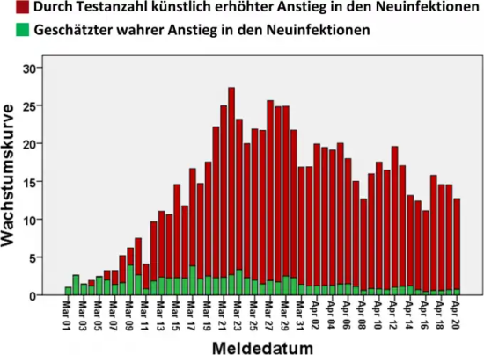](https://swprs.files.wordpress.com/2020/04/zunahme-infektionen-tests-tag.png)Green: Real increase of infected people; red: increase due to more tests.

**Sweden: The media versus reality**

Some readers were surprised by the decrease in deaths in Sweden, as most media show a steeply *rising* curve. What is the reason for this? Most media show *cumulative* figures by date of *reporting*, while the Swedish authorities publish the much more meaningful *daily* figures by date of *death*.

The Swedish authorities always stress that not all newly reported cases have died within the last 24 hours, but many media ignore this (see graph below). Although the latest Swedish figures may still increase somewhat, as in all countries, this does not change the generally declining trend.

In addition, these figures represent deaths *with* and not necessarily *from* coronavirus. The average age of death in Sweden is also over 80 years, about 50% of deaths occurred in vulnerable nursing homes, while the effect on the general population has remained minimal, even though Sweden has one of the [lowest intensive care capacities](https://link.springer.com/article/10.1007/s00134-012-2627-8) in Europe.

However, the Swedish government has also been given [new emergency powers](https://www.tagesschau.de/faktenfinder/ausland/corona-kursaenderung-schweden-103.html) due to “corona” and could still participate in later contact tracing programmes.

[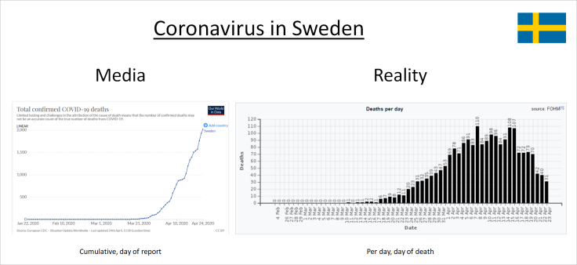](https://swprs.files.wordpress.com/2020/04/sweden-corona-media-vs-reality.png)Cumulative deaths by date of reporting vs. daily deaths by date of death. (OWD / FOHM)

**The situation in Great Britain**

Deaths in the UK have risen sharply in recent weeks, but are still in the range of the [strongest flu seasons](http://inproportion2.talkigy.com/) of the last fifty years (see chart below). In the UK, too, [up to 50%](https://ltccovid.org/2020/04/12/mortality-associated-with-covid-19-outbreaks-in-care-homes-early-international-evidence/) of additional deaths occur in nursing homes, which do not benefit from a general lockdown.

Moreover, [up to 50%](https://www.thetimes.co.uk/edition/news/coronavirus-record-weekly-death-toll-as-fearful-patients-avoid-hospitals-bm73s2tw3) of the additional deaths are said to be non-Covid19 deaths and [up to 25%](https://www.ft.com/content/67e6a4ee-3d05-43bc-ba03-e239799fa6ab) of the additional deaths occur at home. It is therefore not at all clear whether the general lockdown is beneficial or in fact detrimental to society at large.

The editor of the British *Spectator* [has claimed that](https://www.telegraph.co.uk/politics/2020/04/09/boris-worried-lockdown-has-gone-far-can-end/) government agencies expect the lockdown to result in up to 150,000 additional deaths in the longer term, significantly more than what Covid19 is expected to cause. Most recently, the case of a 17-year-old student and singer who took her own life because of the lockdown [became known](https://sports.yahoo.com/coronavirus-bethany-palmer-teenager-death-suicide-152707750.html).

It is striking that England, in contrast to most other countries (including Sweden), has a significantly elevated mortality rate even [among 15 to 64-year-olds](https://www.euromomo.eu/). This could be due to the frequent cardiovascular preconditions, or it might be caused by the [effects of the lockdown](https://www.telegraph.co.uk/global-health/science-and-disease/two-new-waves-deaths-break-nhs-new-analysis-warns/).

The [InProportion project](http://inproportion2.talkigy.com/) has published numerous new graphs that put current UK mortality in relation to previous flu outbreaks and other causes of death. Other websites that critically review the British situation and measures are [Lockdown Skeptics](https://lockdownsceptics.org/) and [UK Column](https://www.ukcolumn.org/).

[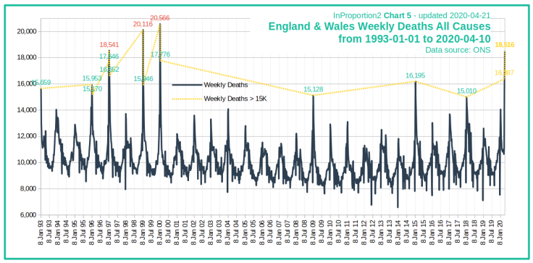](https://swprs.files.wordpress.com/2020/04/inproportion2_chart5.png)UK: Weekly all-cause mortality (InProportion)

**Switzerland: Excess mortality well below strong flu waves**

* A first serological study by the University of Geneva [concluded that](https://www.hug-ge.ch/medias/communique-presse/seroprevalence-covid-19-premiere-estimation) at least six times more people in the canton of Geneva had contact with Covid19 than previously thought. This means that the lethality of Covid19 in Switzerland also falls well below one percent, while official sources still speak of up to 5%.
* Even in the most severely affected canton of Ticino, [almost half](https://www.bluewin.ch/de/news/schweiz/sp-chef-levrat-will-die-reichen-schropfen-383977.html) of the additional deaths occurred in nursing homes that do not benefit from the general lockdown.
* In Switzerland, 1.85 million people or over a third of all employees have already been [registered for short-time work](https://www.bluewin.ch/de/news/schweiz/sp-chef-levrat-will-die-reichen-schropfen-383977.html). The economic costs are estimated at 32 billion for the period from March to June.
* **Infosperber**: [Corona: The parroting of the media](https://www.infosperber.ch/Artikel/Medien/Corona-NZZ-deckt-das-Nachplappern-anderer-Medien-auf). “Major media outlets are hiding the fact that they rely on opaque data for Covid-19 numbers.”
* **Ktipp**: [Swiss authorities: Almost all numbers ‘without guarantee’.](https://www.ktipp.ch/artikel/artikeldetail/bund-fast-alle-zahlen-ohne-gewaehr/) “This year fewer under-65s died in the first 14 weeks than in the last five years. Among the over-65s, the number was also relatively low.”

The following graph shows that overall mortality in Switzerland in the first quarter of 2020 was in the normal range and that by mid-April it was still around 2000 people below the flu wave of 2015. 50% of deaths occurred in [nursing homes](https://www.nzz.ch/zuerich/coronavirus-zuerich-aendert-nun-das-testregime-in-heimenauch-viele-aeltere-covid-19-infizierte-entwickeln-keine-symptome-zuerich-aendert-nun-das-testregime-in-heimen-ld.1552089) that do not benefit from a lockdown.

Overall, around 75% of the additional deaths occurred [at home](https://www.tagesspiegel.de/wissen/woran-sterben-corona-patienten-wirklich-ein-schweizer-forscher-macht-hoffnung-im-kampf-gegen-covid-19/25750666.html), while hospitals and intensive care units remain [heavily underutilized](https://swprs.files.wordpress.com/2020/04/intensivbettenbelegung-schweiz-2020-04-14.png) and numerous operations have been cancelled. In Switzerland, too, the very serious question thus arises as to whether the “lockdown” may have cost more lives than it saved.

[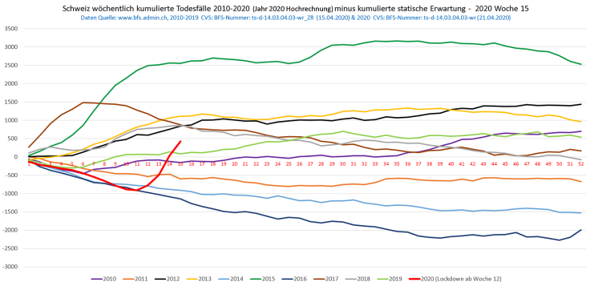](https://swprs.files.wordpress.com/2020/04/schweiz-todesfaelle-2010-2020.png)Cumulated deaths compared to expected value, 2010 to 2020 (BFS)

**Political updates**

* **Video**: In the Australian state of Queensland, a police helicopter with night-vision equipment [tracked down three young men](https://twitter.com/Independent/status/1252911273597120513) who were drinking a beer on the roof of a house at night, thus violating “Corona regulations”. The men were informed via a megaphone that the building is “surrounded by police” and that they must proceed to the exit. The men [were fined](https://www.dailystar.co.uk/news/world-news/police-helicopter-uses-night-vision-21899640) about $1000 each.
* In **Israel**, the domestic and anti-terrorism intelligence agency Shin Bet, in cooperation with the police, [has been tasked](https://www.jewishpress.com/news/the-courts/state-to-high-court-even-more-shin-bet-involvement-in-fighting-the-coronavirus/2020/04/14/) to monitor the population’s mobile phones since mid-March in order to track contacts and order house arrest in the context of Covid19. These measures were initially ordered without the consent of Parliament and are due to remain in place until at least the end of April.
* **OffGuardian**: [The Seven Step Path from Pandemic to Totalitarianism](https://off-guardian.org/2020/04/23/the-seven-step-path-from-pandemic-to-totalitarianism/)
* **UK Column**: [Who controls the British Government response to Covid-19?](https://www.ukcolumn.org/article/who-controls-british-government-response-covid19-part-one)
* The **corona-critical Swiss doctor**, who was arrested by a special unit of the Swiss police and sent to a psychiatric clinic (see update of April 15), has meanwhile been released. A report by the magazine Weltwoche [revealed that](https://uncut-news.ch/wp-content/uploads/2020/04/Wer-l%C3%B6ste-den-Fehlalarm-aus.pdf) the doctor was arrested on false grounds: there had been no threat to relatives or authorities and there had been no possession of a loaded weapon. Thus, a politically motivated operation seems likely.
* A Munich local radio station, which interviewed doctors critical of corona in March, [was informed](https://norberthaering.de/medienversagen/radiomuenchen-blm-meinungsvielfalt/) by the responsible media supervisory authority after complaints that “such problematic broadcasts must be stopped in the future”.
* The website [kollateral.news](https://kollateral.news/) of a German specialist lawyer is collecting reports on “suffering due to the lockdown” and on the actual situation in German hospitals.
* German general practitioners have published an [appeal to politics and science](https://aerzteinnenvorort.de/der-appell) in which they call for “a more responsible handling of the corona crisis”.
* Both in [Austria](https://www.sn.at/panorama/oesterreich/arzt-droht-berufsverbot-wegen-kritik-an-corona-massnahmen-86594140) and in [Hungary](https://magyarhang.org/belfold/2020/04/16/etikai-vizsgalat-indul-az-orvos-ellen-aki-szerint-nincs-jarvany-es-az-idosek-csak-a-felelemtol-halnak-meg/), doctors who have criticised the corona measures are threatened with a ban from their profession.
* In Nigeria, according to official figures, more people have so far been killed [by the police enforcing corona curfews](https://www.bbc.com/news/world-africa-52317196) than by the corona virus itself.

[**Continue to previous updates →**](https://swprs.org/facts-about-covid19-march-2020-archive/)

Share this on: [Twitter](https://twitter.com/intent/tweet?url=https://swprs.org/a-swiss-doctor-on-covid-19/) / [Facebook](https://www.facebook.com/share.php?u=https://swprs.org/a-swiss-doctor-on-covid-19/)

**Swiss Policy Research**

* [Kontakt](https://swprs.org/kontakt/)
* [Übersicht](https://swprs.org/uebersicht/)
* [RSS-Feed](https://swprs.org/feed/)
* [Disclaimer](https://swprs.org/disclaimer/)

**English**

* [About Us / Contact](https://swprs.org/contact/)
* [The Media Navigator](https://swprs.org/media-navigator/)
* [The CFR and the Media](https://swprs.org/the-american-empire-and-its-media/)
* [The Propaganda Multiplier](https://swprs.org/the-propaganda-multiplier/)

**Follow by email**

Top of Form



Bottom of Form

[WordPress.com](https://wordpress.com/?ref=footer_custom_com).

[Up ↑](https://swprs.org/a-swiss-doctor-on-covid-19/)